 | 
Document Type:  Policy | Unique Identifier:  CORP/POL/143
Document Title:  Nutrition Support in Adults | Version Number:  3.2
Document Title:  Nutrition Support in Adults | Status:  Ratified
Scope:  This policy applies to the nutritional needs of all adult patients being cared for by UHMBT colleagues | Classification:  Organisational
Author / Title:  Michelle O’Keeffe, Advanced Dietitian  Jo Halliwell – Quality and Service Improvement Matron | Responsibility:  Integrated Community Care Group
Replaces:  Version 3.1, Nutrition Policy For Adult Inpatients, Corp/Pol/143 | Head of Department:  Kim Crabtree – Assocaite Director of Nursing
Does this document refer to and account for the prescribing, supply, storage or administration of medication (especially via electronic media)? Yes
If yes, Pharmacy Dept. must be consulted and provide approval date below.
Pharmacy Department approval code: RD120922A  To be completed by Pharmacy Department staff | Date: 12/09/2022
Validated By:  Harm Free care | Date:  02/02/2024
Ratified By:  Trust Procedural Document Group | Date:  10/04/2024
Review dates may alter if any significant changes are made | Review Date:  01/02/2027
- Does this document meet the requirements under the Equality Act 2010 in relation to age, disability, gender reassignment, marriage and civil partnership, pregnancy and maternity, race, religion or belief, sex, and sexual orientation? Yes
- Does this document meet our additional commitment as a Trust to extend our public sector duty to carers, veterans, people from a low socioeconomic background, and people with diverse gender identities? Yes

Document for Public Display: No

CONTENTS

1. SUMMARY 3
2. PURPOSE 3
3. SCOPE 3
3.1 Roles and Responsibilities 3
4. POLICY 6
4.1 MUST Screening 6
4.2 Further indications requiring referral to Dietetic team 7
4.3 Departmental communication of patients nutritionally at risk 7
4.4 Protected Mealtimes Policy 7
4.5 Food Provision 8
4.5.1 Patient Choice 8
4.5.2 Healthcare Professionals Responsibility 8
4.5.3 Food from Visitors 8
4.6 Hydration 8
4.6.1 Speech & Language Therapy Guideline 9
4.6.2 Alternative routes 9
4.7 Refeeding Syndrome 9
4.8 Oral Nutritional Supplements (ONS) 9
4.8.1 Dietetic assessment Inpatients 9
4.8.2 Meritene™/Complan™ 10
4.8.3 Availability of ONS for Inpatients 10
4.9 Non-Oral Nutrition Support 10
4.9.1 Enteral Nutrition (EN) - In Patients only 10
4.9.2 Parenteral Nutrition (PN) - Inpatients only 10
4.10 Care of the Dying Patient 10
4.11 Responsibilities on Discharge or Transfer of Care 11
4.11.1 Ward based staff 11
4.11.2 Dietetic Team Inpatients 11
4.12 Training 11
5. ATTACHMENTS 11
6. OTHER RELEVANT / ASSOCIATED DOCUMENTS 12
7. SUPPORTING REFERENCES / EVIDENCE BASED DOCUMENTS 12
8. DEFINITIONS / GLOSSARY OF TERMS 12
9. CONSULTATION WITH STAFF AND PATIENTS 13
10. DISTRIBUTION & COMMUNICATION PLAN 14
11. TRAINING 14
12. AMENDMENT HISTORY 14
Appendix 1: MUST Screening Tool (Lorenzo & EMIS screenshots) 16
Appendix 2: Food and Fluid Record Chart 22
Appendix 3: Emergency Enteral Feeding Regime 23
Appendix 4: Monitoring 26
Appendix 5: Values and Behaviours Framework 27
Appendix 6: Equality & Diversity Impact Assessment Tool 28

SUMMARY
Meeting the nutritional needs of all patients throughout UHMBT is an integral part of effective healthcare. A multidisciplinary approach and the provision of appropriate food and fluids to meet patients’ needs are essential to maximise individual health outcomes.

PURPOSE
The purpose of this policy is to outline the processes involved in optimising the nutritional care of all adult patients during their episode of care in the Trust.

Improving the nutritional care of patients is cited in several key national guidelines and the Trust is committed to ensuring adherence to all relevant standards.

This policy must be followed alongside those policy and procedures outlined within section 6 and best practice outlined within section 7.

SCOPE
This policy applies to the nutritional needs of all patients in UHMBT departments and care groups.

It is the responsibility of all Healthcare Professionals to ensure that nutritional care is an integral part of their practice. It will be followed by all members of staff involved in any stage of the Nutrition Provision

For the purpose of this policy:
- Inpatients pertains to all patients in acute care settings
- Community pertains to all patients living in their own home under the care of a team within the Integrated Community Care Group

Roles and Responsibilities
Nutritional care is a multi-disciplinary responsibility and all staff within the Trust have a responsibility to ensure that patients meet their nutritional requirements.

Role | Responsibilities
Care Group Matrons and Clinical Service Managers | The Care Groups have the responsibility for the development, implementation and reviewing of standards of nutritional care for their patients within UHMBT.
Medical Teams | All medical staff must:  - Lead on ethical decisions in conjunction with multidisciplinary team taking into consideration family/carer views including interpretation of advance directives.  - Recognise that proper nutritional care is fundamental to good clinical practice.  - Identify any nutritional issues.  - Recognise the benefits of appropriate nutritional management and treatment.  - Play an active role in the multi-disciplinary nutritional care of patients.  - Ensure that they seek nutritional education and training relevant to their role.
Ward Nursing Staff (inpatients). | It is the responsibility of nursing staff to ensure:  - A comprehensive nursing assessment is completed on admission for each patient.  - Support patients in meeting identified nutritional needs.  - Screen patients using the electronic Malnutrition Universal Screening Tool (MUST) within 24 hours of admission or on transfers to another ward, or weekly  - Instigate an appropriate treatment plan following screening via MUST  - Maintain accurate food and fluid charts.  - Ensure that any nutritional needs are acted upon.  - Ensure families and Carers are informed and supported with a therapeutic or an alternative diet for religious or cultural reasons.  - Liaise with Catering to ensure patients' needs are supported  - Assist with menu choice as appropriate.  - Facilitate ordering meals at ward level  - Assistant patients to eat and drink where appropriate whilst maintaining the patient’s dignity.  - Educate patients on the impact of nutrition and hydration on their recovery.  - Adhere to the Protected Mealtimes Policy ****.  - Ensure training is completed as outlined within this policy.  - Complete timely referrals to the Dietitian if indicated on MUST and referral to other Healthcare Professionals (HCP) to support a patient’s nutritional needs.  - Implementation of the patient’s treatment plan as specified by the Dietitian, Speech and Language Therapist (SLT) or other members of the Multidisciplinary Team (MDT), reporting any issues with compliance to the relevant health professional.  - If a patient scores 2 or more but a Dietetic referral is not deemed appropriate this must be documented with justification e.g., end of life.
Community Healthcare Professionals – District Nursing, Rapid Response, Virtual Wards, Long Term Conditions, Integrated Care Communities | It is the responsibility of Community Healthcare Practitioners to ensure:  - A comprehensive risk assessment is completed on admission to service.  - Screen patients using the electronic Malnutrition Universal Screening Tool (MUST) as part of the holistic assessment on admission or readmission to service or on transfer to another service or in line with the MUST Screening pathway in section 4.1 for community patients  - Instigate an appropriate treatment plan following screening via MUST  - Ensure that any nutritional needs are acted upon.  - Ensure families and Carers are informed and supported with a therapeutic or an alternative diet for religious or cultural reasons.  - Educate patients on the impact of nutrition and hydration on their recovery.  - Ensure training is completed as outlined within this policy.  - Complete timely referrals to the General Practitioner (GP) to support a patient’s nutritional needs.  - If a patient scores 2 or more but a Dietetic referral is not deemed appropriate this must be documented with justification e.g., end of life.
Department of Nutrition and Dietetics | - Advise and inform the Trust on new initiatives, policies and guidelines in nutrition.  - Maintain evidence-based practice within the Trust regarding Nutrition and Dietetics.  - Assess patients referred following MUST score 2 or above or for therapeutic reasons.  - Create, monitor and review nutritional care plans as agreed with the patient and liaising with appropriate members of the MDT.  - Liaise and work in partnership with the Catering service provider in the creation of the hospital menus, ensuring nutritional standards for catering are met.  - Identify and provide training to catering, nursing and other clinical staff relating to the nutritional care of patients and deliver where appropriate.  - Contribute to audit of MUST screening, Protected Mealtimes and Assistance, to improve/maintain standards of patient care.  - Contribute to health promotion activities, e.g., Nutrition and Hydration week.

POLICY

MUST Screening
Nutritional screening is the first step in identifying patients who may be at nutritional risk (or potentially at risk) and would benefit from appropriate nutritional intervention. It is a rapid, simple and general assessment and it is the responsibility of the healthcare professional to ensure that this takes place.

All inpatients are screened using the electronic MUST tool¹ within 24 hours of admission, on ward transfer or weekly
Community patients will have MUST completed as part of the holistic assessment. This screening must be undertaken by a staff member trained in its use.

In cases where the patient may be unconscious or may be unable to have an objective MUST for other reasons, a subjective MUST can be carried out

MUST must aid rather than replace clinical judgment.

The MUST assessment must be recorded on the electronic patient record on Lorenzo / EMIS

The care plan for patients will follow the pathways below according to the care setting
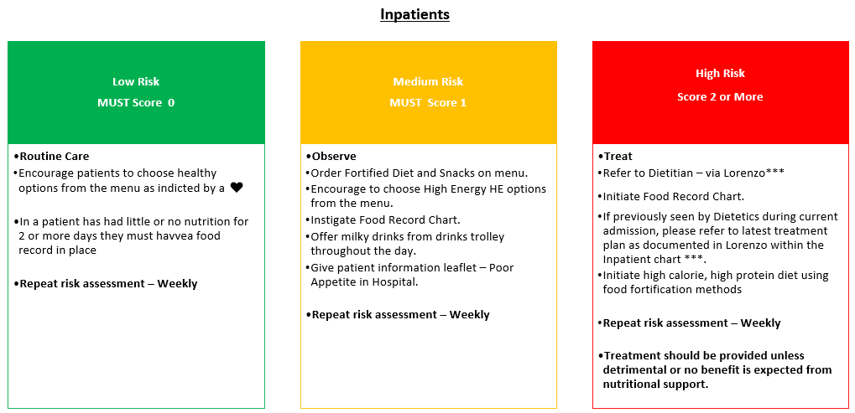
*** Inpatients at Millom hospital would refer to dietitians via telephone and put a treatment plan in place and verbalise this to Millom to be added to EMIS

MUST¹ screening must be repeated weekly for all patients as a minimum, to monitor any changes in a patient’s nutritional status. Changes in a patient’s condition which may affect appetite or ability to eat will be recorded in the electronic records, together with the action taken to safeguard adequate nutritional intake.

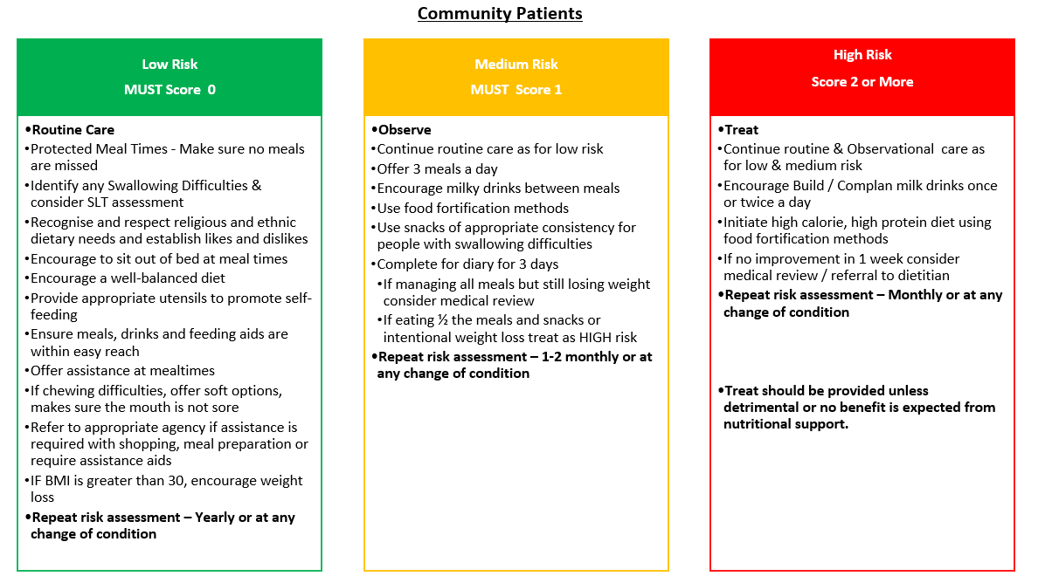

Further indications requiring referral to Dietetic team
- Inpatients in need of a therapeutic diet independent of MUST¹ score must be referred to Dietetic team, e.g. Inflammatory Bowel Disease, renal, stoma issues, micronutrient deficiencies etc. Where appropriate for Inpatient intervention the Dietitian will provide assessment and a treatment plan, which will be documented in Lorenzo or by Community staff in EMIS
- Where deemed appropriate a patient will be offered outpatient intervention.
- Community Patients would be referred their General Practitioner

Departmental communication of patients nutritionally at risk
All departments must have a process to help staff identify patients nutritionally at risk or requiring assistance with food and drink, e.g:
- a wall board above their bed
- ward diet board
- handover documentation
- electronic white board / e- outcome / patient flow

For Community patients this will be documented on EMIS.

Protected Mealtimes Policy
The purpose of a Protected Mealtime Policy is to protect mealtimes from unnecessary and avoidable interruptions. This provides an environment conducive to eating, enabling staff to provide patients with support and assistance with meals which places “food first” at mealtimes.

All non-urgent activities should stop at mealtimes. Diagnostic interventions, non-urgent ward rounds, therapeutic interventions or any other activities that might interfere with the patient’s enjoyment of their meal or interfere with the ward staff’s ability to deliver nutritional care, must be avoided.

Should an inpatient miss a meal, for any reason, it is the responsibility of the healthcare professional taking care of the patient to ensure there is a meal available, e.g. snack box (available always) for them when they are available to eat. If this occurs, it should be documented in the patient’s notes.

See Section 6 - Associated Documents - Protected Mealtime Policy.

Food Provision

Patient Choice
Patients will be given the opportunity and encouraged, whenever possible, to make their own food choices from the standard menu. Patient menu choices will be adapted if clinically indicated, e.g. low fat. Therapeutic menus are available where required, e.g. low residue, texture modification, specials and dementia, patient care choices

Healthcare Professionals Responsibility
It is the responsibility of the healthcare professional to ensure that patients are not subjected to prolonged or unnecessary periods of fasting prior to surgery or investigations. Theatre co-ordinators have a responsibility to inform wards of alterations to operating lists as well as cancellations to minimise fasting.

Food from Visitors
Visitors are allowed to bring in food from home. Department staff must familiarise themselves with foods that are suitable to bring to the wards and how to store them.
If patients are on a special diet, patients and visitors are advised to check with healthcare professionals and the dietitian on the suitability of these items.

Hydration
Hydration is an important element of patient care and UHMBT is committed to ensuring that, where appropriate, patients are encouraged to take adequate fluids by offering a range of drinks throughout the day e.g. water, juice, tea, coffee, milk, soup etc.

Individual requirements for fluids differ according to age, height, weight, medical condition and ambient temperature.

Fluids must be placed within the reach of the patient. Assistance to drink must be provided where necessary.

Fluid intake must be documented on a fluid balance chart where indicated.

Speech & Language Therapy Guideline
The Adult Risk Feeding: Eating and Drinking with Acknowledged Risk of Aspiration CORP/GUID/101 must be followed for patients with Dysphagia, i.e. modified consistency diet and fluids

Alternative routes
If a patient is unable to tolerate oral fluids the use of alternative routes, e.g. enteral, IV for the provision of fluids must be considered.

Refeeding Syndrome
Refeeding syndrome is defined as severe electrolyte and fluid shifts associated with metabolic abnormalities in malnourished patients undergoing refeeding, whether orally, enterally or parenterally. (Crook et al 2001³)

This may be a life-threatening complication in the first days after the start of feeding in severely malnourished patients. Clinical presentations are non-specific and can include arrhythmias, muscle weakness, signs of respiratory and/or cardiac failure, oedema, lethargy or seizures.

Risk of refeeding is minimised by slowly introducing nutrition and gradually increasing over several days in at risk patients.

Throughout this period there should be daily monitoring and if required replacement of electrolytes together with Thiamine, Vitamin B co strong (or intravenous vitamin B preparation, if necessary) and a balanced multivitamin/trace element supplement

Section 6 – Associated Documents - Refeeding guidelines
Section 7 – Supporting References – NICE, Nutritional Support for Adults 2006⁴

Oral Nutritional Supplements (ONS)

Dietetic assessment Inpatients
Dietetic Assessment may identify ONS to be appropriate for individual inpatients. In Millom hospital this assessment would be completed by General Practitioner / CHOC / ACP These will be documented on the patient’s prescription chart.

In order to maximise the full benefit of ONS the following points must be noted:
- Ensure the correct ONS, as documented on the patient’s prescription chart, is offered.
- ONS is usually recommended in addition to meals and not as a meal replacement unless specified otherwise by a Dietitian.
- ONS should be offered at suitable times for the patient, i.e. in between meals or after meals. They should not be offered just prior to serving a meal or during a meal.
- Consideration is given to patient’s preferred choice of flavour, temperature and presentation.
- Type and amount of ONS consumed should be documented on the food record and / or fluid charts.
- Ward staff to inform the Dietitian if the patient is not tolerating their ONS.

Meritene™/Complan™
Inpatients - ONS must not be given to patients unless documented on their prescription chart with the exception of Meritene™ and Complan™ where a maximum of two a day can be offered.
Community – patients must be encouraged to have the prescribed ONS at all visits

Availability of ONS for Inpatients
For inpatients Pharmacy and / or Dietetics must be contacted if there are any issues of availability of any ONS.

Non-Oral Nutrition Support

Enteral Nutrition (EN) - In Patients only
- EN is the administration of nutrition via a tube into the gastrointestinal tract. This includes nasogastric, gastrostomy, jejunostomy and naso-jejunal feeding.
- Patients who have a functioning gastrointestinal tract requiring non-oral nutritional support must be fed enterally as this maintains gut integrity.
- EN is classed as a medical intervention and requires consent (verbal or written), this needs to be documented in the patient’s electronic record.
- EN can be delivered as a sole source of nutrition or as a supplement to oral diet and fluids.
- All Inpatients being considered for EN must be referred to the Dietitian if not previously identified and referred following MUST screening.

See Section 6 for UHMBT documents regarding Emergency feeding regime / stroke pathway / refeeding / Insertion and verification of nasogastric feeding tubes / ethical
See Section 7 for link to NICE⁴ and BAPEN guidelines⁵

Parenteral Nutrition (PN) - Inpatients only
- Parenteral Nutrition is the administration of nutrition via a dedicated peripheral or central venous catheter.
- PN must only be used when the oral / enteral route is inaccessible, or the gastrointestinal tract is non-functional.
- PN is classed as a medical intervention and requires consent (verbal or written), this needs to be documented in the patient’s electronic record.
- All patients being considered for PN must be referred to the Dietitian if not previously identified and referred following MUST screening.
- PN is a POM (prescription only medication) and must be prescribed.

See Section 6 for link to UHMB TPN Supply and prescribing / Practice and ethic of Nutritional Support in Medical Patients
See Section 7 for link to NICE⁴ and BAPEN guidelines⁵

The Integrated Community Care Group do not support the use of 4.9.1 & 4.9.2 on their caseload.

Care of the Dying Patient
- Options regarding hydration and feeding in the dying patient must be discussed and agreed with the patient and their relative(s)/carer(s).
- If there are concerns regarding the safety of patient’s swallow, they may still elect to eat / drink however if there are issues regarding mental capacity, please refer to the Mental Capacity Act 2005 & The Adult Risk Feeding: Eating and Drinking with Acknowledged Risk of Aspiration CORP/GUID/101
- Consider of MUST will be complete don an individual basis depending on patients care needs and wishes

Responsibilities on Discharge or Transfer of Care

Ward based staff
Ward based staff must provide:
- Information regarding Nutritional Screening and any special nutritional needs must form part of every medical and nursing discharge / transfer summary.
- Dietitian with advance notice of home enteral feeding patient discharge plans.
- A 7-day supply of prescribed nutritional products / ancillaries from ward stock where indicated from Dietetic treatment plan. This is in accordance with UHMB Policy.
- Referral to relevant healthcare professionals/agencies within the community as appropriate, e.g. Social Services; Homecare Agencies.

Dietetic Team Inpatients
Dietetic team should provide:
- Information for patient / carers regarding their ongoing Dietetic treatment plan and follow up.
- Information to patient’s GP where ongoing prescriptions for nutritional products or supplements is required.
- Home enteral feeding pump and stand.
- Access to training to ensure effective and safe home enteral feeding.
- Information regarding ongoing supply of nutritional products and ancillaries.
- Liaison with external agencies for advice and training where appropriate.

Training
All staff in in-patient setting must completed MUST – e-Learning to undertake MUST assessment.

For community patients' staff will be expected to complete BAPEN e-learning

ATTACHMENTS
Number | Title | Separate attachment
1 | MUST Screening Tool – Lorenzo Screen Shots | N
2 | Food Chart | N
3 | Emergency Enteral Feeding Regime | Y
4 | Monitoring | N
5 | Values and Behaviours Framework | N
6 | Equality & Diversity Impact Assessment Tool | N

OTHER RELEVANT / ASSOCIATED DOCUMENTS
The latest version of the documents listed below can all be found via the Trust Procedural Document Library intranet homepage or the Nutrition & Dietetics SharePoint page (links provided)
Unique Identifier | Title
ACU/Guid/001 | Fluid Balance Monitoring
ACU/Guid/001  (attachment) | Fluid balance chart
Corp/Proc/032 | Protected Mealtimes Policy
Corp/Proc/050 | Insertion and verification of nasogastric feeding tubes
Stroke/SOP/002 | Nutrition Post-Stroke
Corp/Pol/122 | TPN ordering, prescribing and supply
Corp/Strat/005 | Food and Drink Strategy
Poor Appetite leaflet –
Poor Appetite in hospital reformatted.docx
Corp/Guid/101 | Adult Risk Feeding - Eating and Drinking with Acknowledged Risk of Aspiration
Refeeding Guidelines
GM/Guid/016 | Practice and Ethics of Nutritional Support in Medical Patients - Medical Guidelines
Corp/Pol/143 (Appendix 3) | Emergency Enteral Feeding Regime
Corp/Pol/143 (Appendix 3) | Refeeding guidelines

SUPPORTING REFERENCES / EVIDENCE BASED DOCUMENTS
Every effort been made to review/consider the latest evidence to support this document? |  | Yes
If ‘Yes’, full references are shown below:
Number | References
1 | BAPEN (2015) ‘Malnutrition Universal Screening Tool’ (MUST) (accessed 16.4.24)
2 | NICE (2006 - updated 2017)’ Nutritional support for adults: oral nutrition support, enteral tube feeding and parenteral nutrition (accessed 16.4.24)

DEFINITIONS / GLOSSARY OF TERMS
Abbreviation or Term | Definition
The relevant terms and their definitions (within the context of this policy document) are outlined below.
Malnutrition | Malnutrition is a state in which a deficiency of nutrients such as energy, protein, vitamins and minerals causes measurable adverse effects on body composition, function or clinical outcome.  - The Trust recognises that there are particular physical health conditions with intrinsic consequences for nutrition such as diabetes and high blood cholesterol. Long term mental health condition can compromise nutritional status. The Trust will ensure that specialist advice, support and interventions will be provided and that specific Department of Health guidance relating to these, and other such conditions will be followed.  - Trust will work in partnership with service users and carers to promote good nutrition and hydration as part of a healthy lifestyle, which is in keeping with a recovery focused approach and improving physical health.
Nutrition support for malnourishment | Nutrition Support should be considered in people who are malnourished (undernourished), as defined by any of the following:  - A body mass index (BMI) of less than 18.5 kg/m²  - Unintentional weight loss greater than 10% within the last 3-6 months  - (c) A BMI of less than 20 kg/m2 and unintentional weight loss greater than 5% within the last 3-6 months.
Nutrition support for malnutrition | Nutrition support should be considered in people at risk of malnutrition, defined as those who have:  - Eaten little or nothing for more than 5 days and/or are likely to eat little or nothing for 5 days or longer.  - A poor absorptive capacity and/or high nutrient losses and/or increased nutritional needs from causes such as catabolism.  NB – A person may be malnourished but not underweight due to poor diet, substance misuse or physical illness.  The term Malnutrition also describes ‘over nutrition’ (overweight/obesity) which can cause health problems
Dysphagia | Dysphagia is a term used to describe swallowing disorders that may occur in the oral and/or pharyngeal stages of eating and drinking. These can arise from a wide range of neurological, structural, psychological and organic conditions including the dementias. People with mental health conditions are more at risk of experiencing swallowing problems and choking.
Obesity | Obesity is defined in terms of Body Mass Index (BMI): BMI is a measure that is used to see if an adult is a healthy weight for their height.

CONSULTATION WITH STAFF AND PATIENTS
Enter the names and job titles of staff and stakeholders that have contributed to the document
Name/Meeting | Job Title | Date Consulted
Andrea Jackson | Senior Infection Prevention Nurse | 31/08/2023
Barry Rigg | Head of Patient Experience, UHMBFT | 31/08/2023
Bridget Lees | Chief Nursing Officer, UHMBFT | 31/08/2023
Jackie O’Brien | Catering Manager, RLI, UHMBFT | 31/08/2023
Janette Brassey | Specialist Dietitian, RLI, UHMBFT | 31/08/2023
Jane McNicholas | Medical Director, UHMBFT | 31/08/2023
Kam Mom | Chief Pharmacist & Accountable Officer for Controlled Drugs UHMBFT | 31/08/2023
Lucy Budden | Team Manager, Nutrition & Dietetics, FGH and WGH, UHMBFT | 31/08/2023
Pauline Fox | Transformation Lead, UHMBFT | 31/08/2023
Sally Young | Quality Assurance Matron, UHMBFT | 31/08/2023
Tracy Litt | Catering Manager, FGH and WGH, UHMBFT | 31/08/2023
Yvonne Hastings | Clinical Service Manager - Community Nursing | 31/08/2023

DISTRIBUTION & COMMUNICATION PLAN
Dissemination lead: | Nutrition Strategy Group
Previous document already being used? | Yes
If yes, in what format and where? | Procedural Documents Library
Proposed action to retrieve out-of-date copies of the document: | Replace the document within the library
To be disseminated to:
Document Library | Yes
Proposed actions to communicate the document contents to staff: | Include in the UHMB Friday Corporate Communications Roundup – New documents uploaded to the Document Library

TRAINING
Is training required to be given due to the introduction of this procedural document? Yes
If ‘Yes’, training is shown below:
Action by | Action required | To be completed (date)
Manager / Team Leader | At induction | Start Date

AMENDMENT HISTORY
Version No. | Date of Issue | Page/Selection Changed | Description of Change | Review Date
1.1  FINAL | Mar 2012 | 8  9  10  17 | Amendments to reporting flow chart  New web link GMC  Link nurse responsibilities  Monitoring compliance and links to screening tool and Protected Mealtime Policy  Removed terms of reference for NSG
1.2  FINAL | Oct 2013 | 4  8  9  11  14  16  17  18 | Amendments to Quality and Impact assessment Tool  Amendments to scope including references  Amendments to reporting flow chart  Alternation of terminology of NQAT to CQAT  Amendments to provision for inpatients – Menu  Amendments to provision for inpatients – ONS Oral Nutritional supplements  Addition of section “Patients Requesting Food Brought In From Home”  Addition of section “Protected Mealtimes”  Addition of References
1.3 | 17/09/2015 | Page 1 | Review date extended from 10/10/2015 to 30/11/2015 agreed at 16.9.15 meeting | 30/11/2015
1.4 | 06/10/2016 | Page 1 | Review Date extended to 01/12/2016 | 01/12/2016
1.5 | 04/01/2017 | Page 1 | Review Date extended – form 147/2016 | 01/08/2017
1.6 | 26/06/2017 | All | Converted to latest procedural document template | 01/08/2017
1.7 | 20/09/2017 | Page 1 | Review Date extended – form 161/2017 | 01/01/2018
1.8 | 14/02/2018 | Page 1 | Review Date extended – form 009/2018 | 01/04/2018
2 | 14/03/2018 | Document | Document amended to new format and terms of reference | 01/06/2021
2.1 | 09/05/2022 | Review Date | Review date extended #572 | 01/09/2022
3 | 10/04/2024 | Whole document | Document transferred to new template | 01/02/2027
3 | 10/04/2024 | Page 14 Section 6 | Section and Links to documents updated | 01/02/2027
3 | 10/04/2024 | Page 14 and 15 Section 7 | Links to documents reviewed and updated | 01/02/2027
3 | 10/04/2024 | Page 16 Section 9 | Updated and recirculated for review | 01/02/2027
3 | 10/04/2024 |  | Throughout to include ICCG | 01/02/2027
3.1 | 26/06/2024 | Appendix 3 | Refeeding Syndrome Guidance updated | 01/02/2027
3.2 | 29/04/2025 | Appendix 3 | Feed choices updated due to stock issues | 01/02/2027

Appendix 1: MUST Screening Tool (Lorenzo & EMIS screenshots)

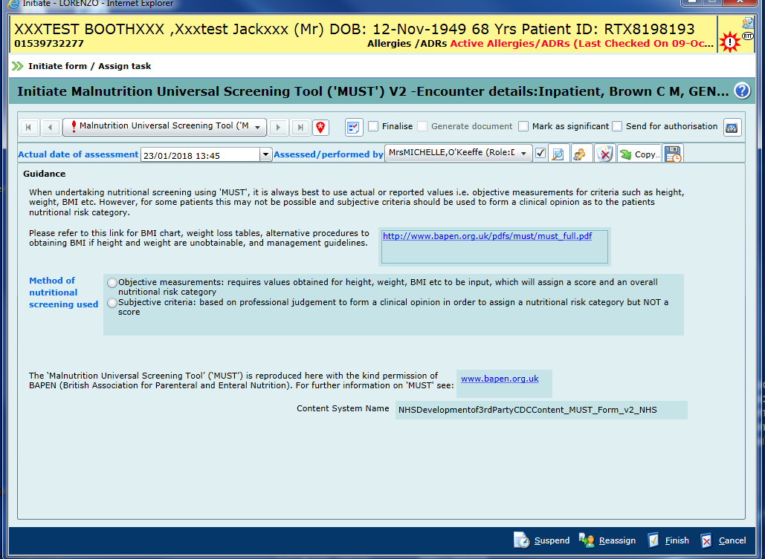

Within this screen you need to choose between:
- objective measurements
- subjective measurements

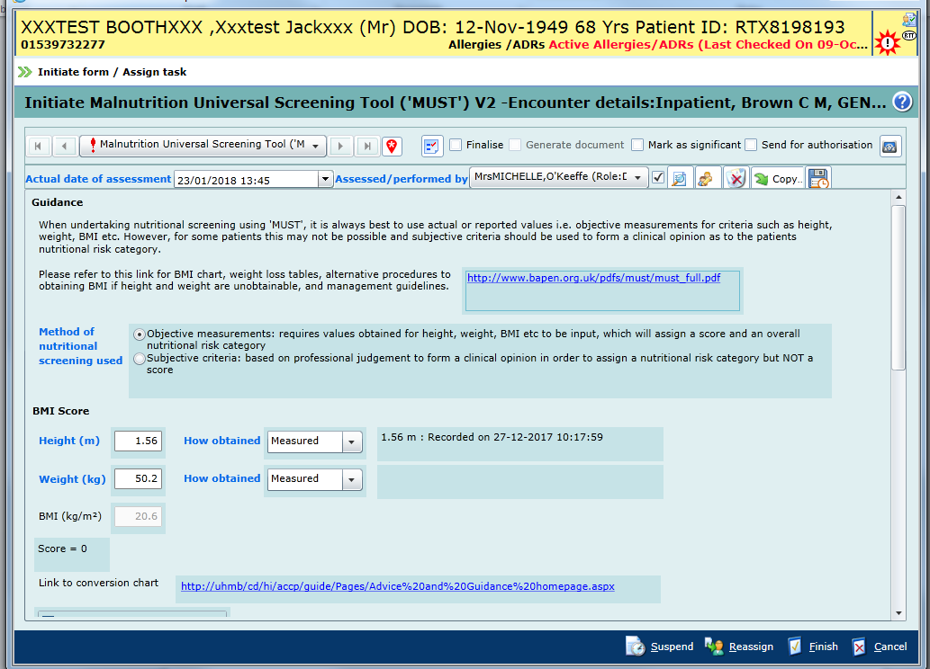

If you have chosen objective measurements, you will need to input height (m) and weight(kg), the BMI will be automatically calculated.
Remember to input how these measurements were obtained

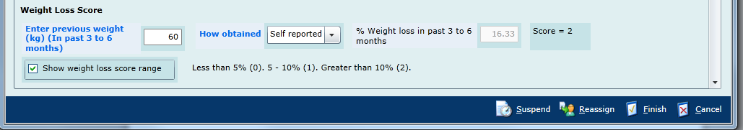

Enter the patient’s previous weight from the past 3-6 months to generate a weight loss score

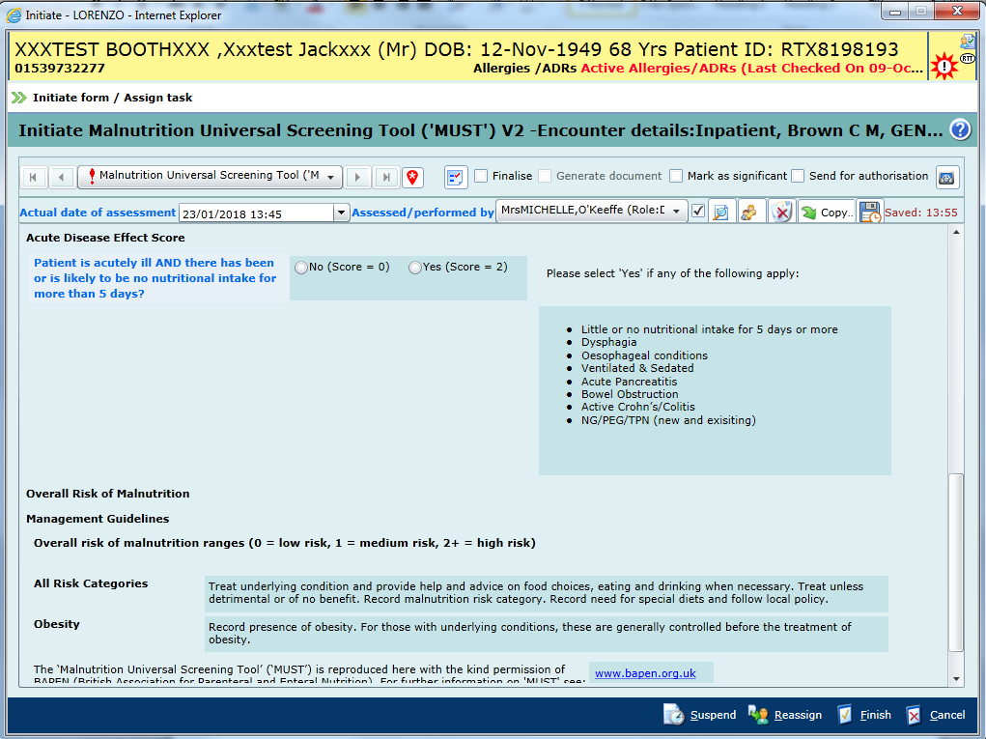

Refer to the bullet point list to determine whether the patient scores for ‘Acute Disease’

MUST Score Treatment Plans
MUST Score 0

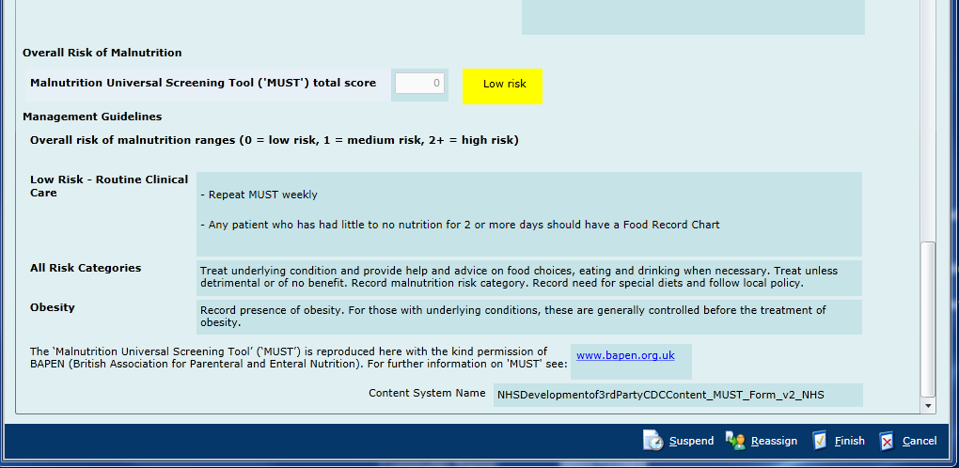

Follow the management guidelines as above

MUST Score 1
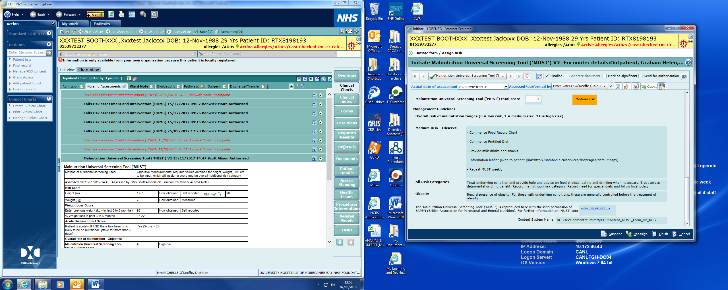
Follow the management guidelines as above

MUST Score 2 or above

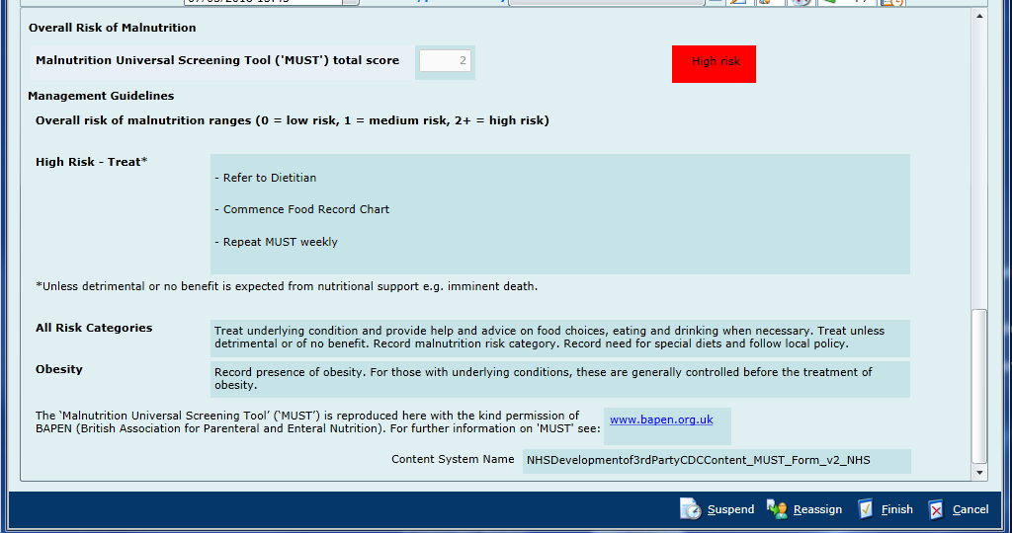

Please follow the management guidelines as above

EMIS MUST Tool

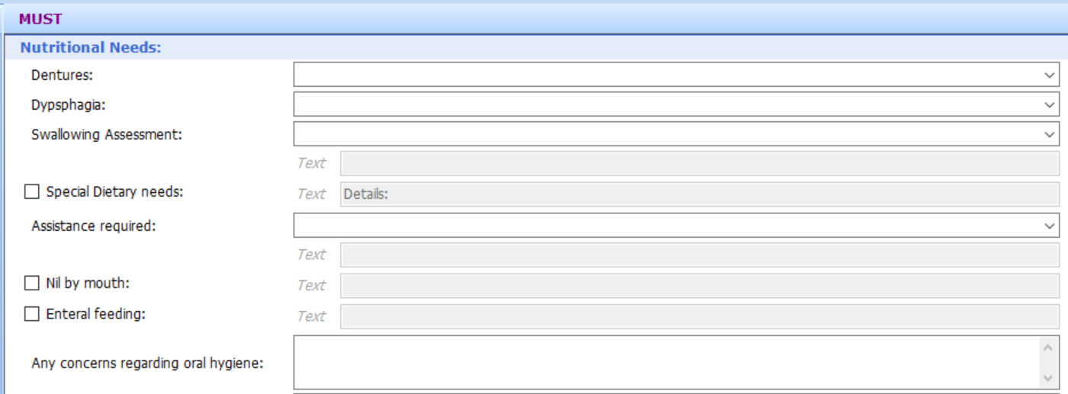

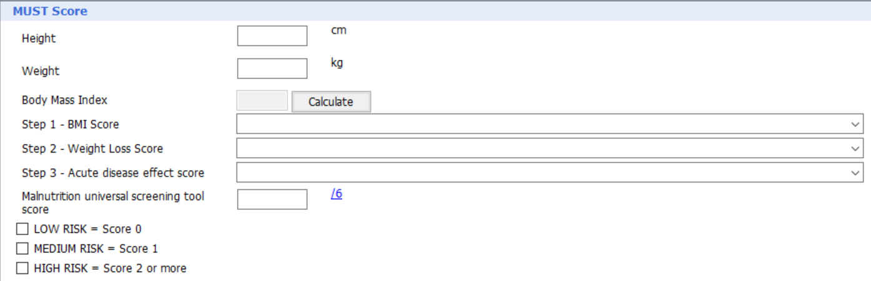

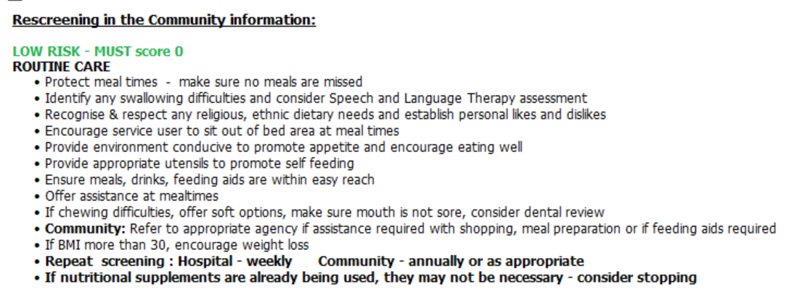
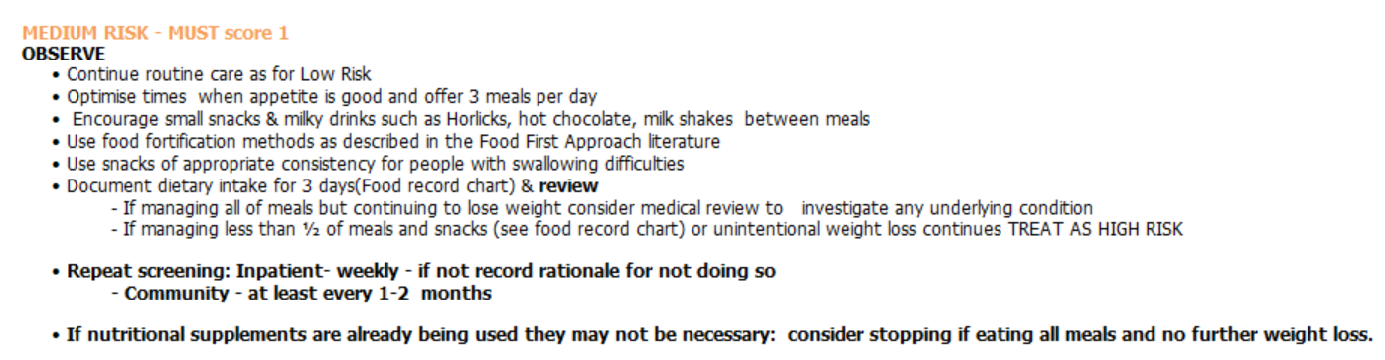

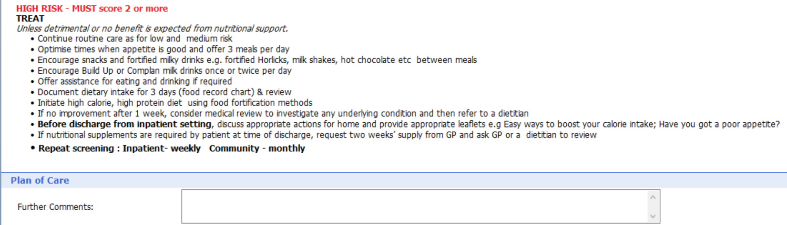

Appendix 2: Food and Fluid Record Chart

Date:

Meals,

Snacks & Drink

T
ype

Amount of food

& drink
eaten

V
olume

0

¼

½

¾

All

(ml)

Breakfast

Cereal

T
oast / Bread

Butter /
J
am

Drinks (mls)

Mid
-
Morning

Drinks (mls)

Sna
c
ks

Lunch

Soup

Me
a
t / Fish

P
ots /
P
asta / Rice

V
e
g
et
a
bles

Sandwi
c
h

Desse
r
t

Drinks (mls)

Mid
-
Afternoon

Drinks (mls)

Sna
c
ks

Evening Meal

Soup

Me
a
t / Fish

P
ots /
P
asta / Rice

V
e
g
et
a
bles

Sandwi
c
h

Desse
r
t

Drinks (mls)

Supper

Drinks (mls)

Sna
c
ks

Supplements

T
ype

T
ype

T
ype

Fluid
T
O
T
AL

(mls)

Action

Date:

Meals,

Snacks & Drink

T
ype

Amount of food

& drink
eaten

V
olume

0

¼

½

¾

All

(ml)

Breakfast

Cereal

T
oast / Bread

Butter /
J
am

Drinks (mls)

Mid
-
Morning

Drinks (mls)

Sna
c
ks

Lunch

Soup

Me
a
t /
Fish

P
ots /
P
asta / Rice

V
e
g
et
a
bles

Sandwi
c
h

Desse
r
t

Drinks (mls)

Mid
-
Afternoon

Drinks (mls)

Sna
c
ks

Evening Meal

Soup

Me
a
t / Fish

P
ots /
P
asta / Rice

V
e
g
et
a
bles

Sandwi
c
h

Desse
r
t

Drinks (mls)

Supper

Drinks (mls)

Sna
c
ks

Supplements

T
ype

T
ype

T
ype

Fluid
T
O
T
AL

(mls)

Action

Use sti
c
k
er if

a
vail
a
ble

Name:
R
TX:
W
ard:

Food and Fluid Record Chart

Date:

NOTE:
R
ecord
ALL
f
ood and fluid inta
ke
.

When recording fluid, document only the
v
olume
ta
k
en in the last column and add up the total.

Meals,

Snacks & Drink

T
ype

Amount of food

& drink
eaten

V
olume

Breakfast

Cereal

T
oast / Bread
Butter /
J
am
Drinks (mls)
Mid
-
Morning
Drinks (mls)
Sna
c
ks
Lunch

Soup

Me
a
t / Fish

P
ots /
P
asta / Rice
V
e
g
et
a
bles
Sandwi
c
h

Desse
r
t Drinks
(mls)
Mid
-
Afternoon
Drinks (mls)
Sna
c
ks
Evening Meal
Soup

Me
a
t / Fish

P
ots /
P
asta / Rice
V
e
g
et
a
bles
Sandwi
c
h

Desse
r
t
Drinks (mls)
Supper
Drinks (mls)
Sna
c
ks

Supplements

T
ype
T
ype
T
ype

Action

0

¼

½

¾

All

(ml)

Fluid
T
O
T
AL

(mls)

Aug 2022 Review Jun 2026

Appendix 3: Emergency Enteral Feeding Regime
Link to printable version: Emergency Enteral Feeding.docx
Emergency Enteral Feeding


REFER TO THE DIETITIAN AS SOON AS POSSIBLE – via E-referral ideally.
- Contraindications to starting feed, e.g. Bowel disorder/disease, food allergy or intolerance
- Please consider refeeding syndrome (see appendix 1)
NB: for those at extremely high risk do not feed until seen by a dietitian

If a patient is admitted with a PEG/RIGG/PEJ/JEJ:
- Please contact the Nursing home or Care Home as soon as possible if the patient was not sent with an up-to-date tube feeding regimen.
- If the patient is usually on a feed that we do not stock, please ask the NH/CH to provide this as soon as able.
- If a patient has come from their own home, please ask, if possible, for a family member or friend to provide the feed and regimen from home.
- Please look under the Clinical notes tab OR the evaluations tab for the most recent “Dietetic assessment” or “Enteral Feeding Regimen” – “HETF regimen” – if the patient is not from out of area this should be available.
- If none of the above is available, please use emergency feeding regimen below.

Confirm position of NG tube prior to commencing feed or administering flushes or medications via the tube. See guide for insertion and verification of NG tubes.

If a dietitian is not available, commence feeding as below:

Name of feed: Nutrison Multifibre
(if Nutrison Multifibre is not available, please use Fresubin Original Fibre as 1st choice or Nutrison 1000 Complete Multifibre as 2nd choice)
Timing: 20 hours (some enteral medications will require specific rest periods, e.g. phenytoin, ciprofloxacin etc. as they interact with feed – please seek advice from pharmacy)
Rest period: 4 hours
Other details: Flush tube with 50ml water before and after feed and at pack change
Flush tube with 50ml pre and post medications and at least 10ml in between each medication.
Additional fluids are likely to be required whilst feed volume is increasing – please liaise with doctors.
Monitor bloods (general profile) daily until stable.

Please see below table to establish daily rate for feeding:

Table 1: Daily pump feeding rate depending on age, increasing to be close to meeting estimate needs by day 5 (based on 25kcal/kg and mid-range weight)
Patient weight (kg) | Day 1 (ml/hr) | Day 2 (ml/hr) | Day 3 (ml/hr) | Day 4 (ml/hr) | Day 5 (ml/hr)
30-39 | 15 | 20 | 25 | 35 | 44
40-49 | 20 | 25 | 30 | 40 | 56
50-59 | 25 | 33 | 40 | 50 | 68
60-69 | 30 | 35 | 45 | 60 | 81
≥70 | 35 | 45 | 55 | 70 | 94

NB These should be used as a guide for the rate to be prescribed. However, other factors must be taken into consideration, e.g. fluid restriction, co-morbidities etc.

In enterally fed patients who are known diabetics, please refer to the Inpatient Diabetes Specialist Nurses for review.
In patients who are not known diabetics, please provide blood glucose monitoring if indicated based on clinical condition/medication (e.g. steroids) or if deemed at risk of diabetes or if pre-diabetic.

Important Notes:
- Use a new giving set/syringe every 24 hours
- Patient should be positioned at an angle of >45° during feeding and for at least one hour after feeding stops, to reduce risk of aspiration
- If at any time feed is not tolerated, reduce to previous rate and contact dietitian
- If feed is not tolerated, discontinue feed and seek medical advice. Symptoms might include abdominal distension, nausea and vomiting, indigestion, reflux, diarrhoea, abdominal pain

Refeeding Syndrome
Guidance (Appendix 1)


Definition of Refeeding Syndrome
Severe fluid and electrolyte shifts associated with initiating nutritional support in malnourished patients and the metabolic implications which occur as a result of this (Solomon and Kirkby, 1990)

Monitoring and Treatment (NICE Clinical Guideline 32, 2006)
- Monitoring potassium, magnesium, phosphate and corrected calcium daily until stable
- Ask a doctor to prescribe immediately before and during the first days of feeding:

Oral treatment for 10 days:
Oral thiamine 100mg THREE times a day
AND
Vitamin B Co-Strong 2 tablets THREE times a day

If unable to swallow, thiamine may be crushed and given via NG tube and Vigranon B oral liquid 10ml THREE times a day may be used instead of vitamin B co strong tablets.

OR:
- Full dose daily intravenous Vitamin B preparation, e.g. Pabrinex (1 pair of ampoules ONCE a day for 3-5 days depending on dietetic recommendation)
- or if unavailable, intravenous Thiamine 200-300mg initially prior to starting parenteral nutrition continue for at least 2 more days (total course of 3 days); or 4 more days (total course of 5 days) in higher-risk patients

AND
Complete multivitamin and mineral supplement (forceval capsule or soluble).

Identifying Patients At Risk

At Risk
Any patient who has had very little or no food intake for greater than 5 days

High Risk
Any patient who has one or more of the following:
- BMI less than 16kg/m²
- Unintentional weight loss greater than 15% within the last 3-6 months
- Little or no nutritional intake for greater than 10 days
- Low levels of potassium, phosphate or magnesium prior to feeding

OR a patient who has two or more of the following:
- BMI less than 18.5kg/m²
- Unintentional weight loss greater than 10% within the last 3-6 months
- Little or no nutritional intake for greater than 5 days
- A history of alcohol abuse or drugs including insulin, chemotherapy, antacids or diuretics

Extremely High Risk
- Patients in a starved state with a BMI less than 14kg/m²
- Very little or no nutrition for greater than 15 days

Dietetic contact details:
RLI (01524 519380 (Ext. 49380))
FGH (01229 403968 (Ext. 43968))

Appendix 4: Monitoring

What is to be monitored? | Methodology (incl. data source) | Frequency | Reviewed by | Group / Committee to be escalated to (if applicable)
4.1 MUST screening | Qlik Sense application | Weekly | Ward managers and matrons | Harm Free Care
4.1 MUST screening | Clinical Incidents (Ulysses) | monthly | Quality and Service Improvement team | ICCG Quality and Governance Group
Section 4 | Patient Lead Assessment of the Care Environment | Annual | Estates Facilitaties Group  Patient Experience and Involvement Group | NHS ENgland

Appendix 5: Values and Behaviours Framework

To help create a great place to work and a great place to be cared for, it is essential that our Trust policies, procedures and processes support our values and behaviours. This document, when used effectively, can help promote a positive workplace culture. By following our own policies and with our ambitious drive we can cultivate an open, honest and transparent culture that is truly respectful and inclusive and where we are compassionate towards each other.
For further information, you can also refer to Our People Strategy online. This aligns with the NHS People Promise and helps outline our commitments to working together to make UHMBT a great place to work.
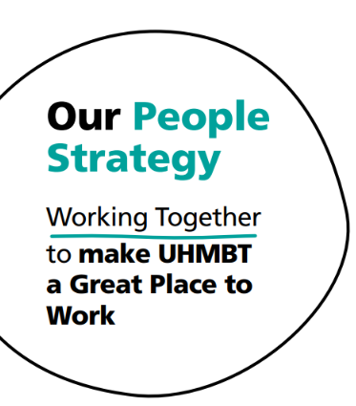
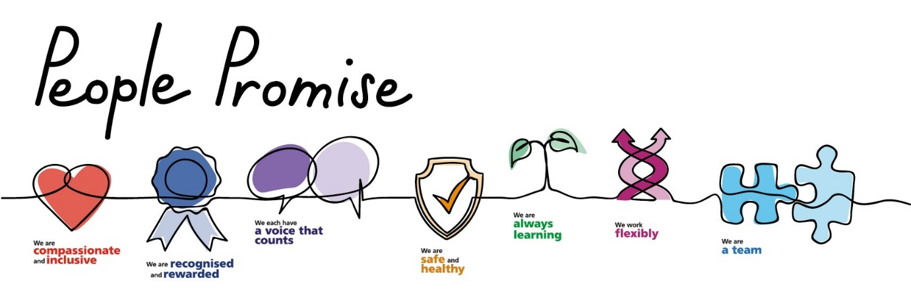

Appendix 6: Equality & Diversity Impact Assessment Tool

Equality Impact Assessment Form
Department/Function |  | Nutrition & Dietetics
Lead Assessor |  | Michelle O’Keeffe
What is being assessed? |  | Nutrition Policy for Adult Inpatients
Date of assessment |  | 11/01/2024
What groups have you consulted with? Include details of involvement in the Equality Impact Assessment process. |  | Network for Inclusive Healthcare? |  |  | NO
 |  | Staff Side Colleague? |  |  | NO
 |  | Service Users? |  |  | NO
 |  | Staff Inclusion Network(s)? |  |  | NO
 |  | Personal Fair Diverse Champions? |  |  | NO
Other (including external organisations):
Dietetic Leads
Pharmacy

- What is the impact on the following equality groups?
Positive:  - Advance Equality of opportunity  - Foster good relations between different groups  - Address explicit needs of Equality target groups |  | Negative:  - Unlawful discrimination / harassment / victimisation  - Failure to address explicit needs of Equality target groups |  | Neutral:  - It is quite acceptable for the assessment to come out as Neutral Impact.  - Be sure you can justify this decision with clear reasons and evidence if you are challenged
Equality Groups | Impact  (Positive / Negative / Neutral) |  | Comments  - Provide brief description of the positive / negative impact identified benefits to the equality group.  - Is any impact identified intended or legal?
Race  (All ethnic groups) | Neutral
Disability  (Including physical and mental impairments) | Neutral
Sex | Neutral
Gender reassignment | Neutral
Religion or Belief | Neutral
Sexual orientation | Neutral
Age | Neutral
Marriage and Civil Partnership | Neutral
Pregnancy and maternity | Neutral
Other (e.g. carers, veterans, people from a low socioeconomic background, people with diverse gender identities, human rights) | Neutral

- In what ways does any impact identified contribute to or hinder promoting equality and diversity across the organisation?
- If your assessment identifies a negative impact on Equality Groups you must develop an action plan to avoid discrimination and ensure opportunities for promoting equality diversity and inclusion are maximised.
- This should include where it has been identified that further work will be undertaken to further explore the impact on equality groups
- This should be reviewed annually.
Action Plan Summary
Action |  | Lead | Timescale
NA

This form will be automatically submitted for review once approved/noted by Trust Procedural Document Group.
For all other assessments, please return an electronic copy to EIA.forms@mbht.nhs.uk once completed.

