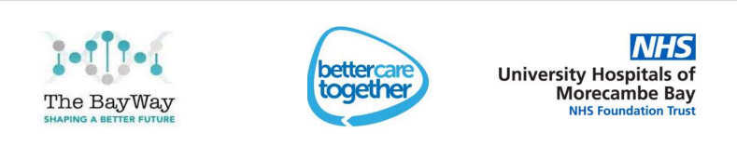

Workforce Race Equality Standard Report
2024-2025

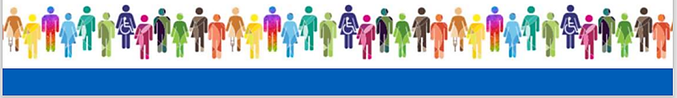

Provider Organisation:
University Hospitals of Morecambe Bay NHS Foundation Trust
Date of Report
July 2025
Board Lead for the Workforce Race Equality Standard:
Alison Balson, Chief People Officer
Lead Manager compiling this report:
Amal Ramadan, Diversity & Inclusion Advisor

Table of Contents

- Background
- Summary of Data
- Representation, Recruitment and Progression
Indicator 1: Representation
Indicator 9: Board voting membership
Indicator 2: Likelihood of appointment
Indicator 4: Access to training and CPD
Race Disparity Ratio
Indicator 7: Fairness in career progression
- Formal disciplinary processes
Indicator 3: Likelihood of entering disciplinary
Narrative and action
- Behaviours and discrimination
Indicator 5: Bullying and harassment from the public.
Indicator 6: Bullying and harassment from staff.
Indicator 8: Experience of discrimination
- Action plan: General Narrative and Action Plan

- Background
Executive Summary:
This report gives an overview of the Workforce Race Equality Standard (WRES) and the nine metrics we report against. It provides a brief analysis of the UHMBT WRES data against each metric and explores trends internally with previous years’ data and the Trust comparators. The report highlights progress against these standards during 2024-25 and identifies the key priorities for 2025-26.
Scope of the Workforce Data:
The WRES data included in this report has been obtained from the following sources:
• Electronic Staff Records [ESR].
• Human Resource Team records.
• NHS Staff Survey.
The period the organisation's data refers to is staff in the post as of 31st March 2025; Financial Year 2024/25 for all relevant indicators.
The considerations for WRES in this report are commissioned and are overseen by the NHS Equality and Diversity Council and NHS England.

Reliability of comparisons with previous years:
No issues were identified.


Improvement and sustained positive outcomes:
- Indicators 1: Ethnic minority colleagues’ representation this year is 18.86%. This is great increase of BAME colleagues’ representation compared to the last year’s figure 15.89%

- Indicator 6: 24.3% of ethnic minority staff and 23.4% of white staff have experienced bullying, harassment or abuse from staff in the last 12 months – This figure considerably decreased compared to the 2024 figure of 26.8% and compared to the 2023 figure of 32.1%. A sustained continuous improvement has been made in this area.

- Indicator 7: 53.9% of ethnic minority staff and 55.7% of white staff believe the Trust provides equal opportunity for career progression. This figure was significantly increased from the 2024 figure of 52.6% and from the 2023 figure of 48.6%. Continuous sustained improvement is made in this area.

- Indicator 8: 16.8% of ethnic minority staff and 6.8% of white staff have experienced discrimination from staff in the last 12 months – this is a considerable improvement compared to the 18.3% figure in 2024 and from the 2023 figure of 22.4%. Broadly sustaining significant improvements was made in this area.

- Indicators 9: 23.1% of the Board's voting membership has an ethnic minority background, compared with an overall workforce of 18.9%; This is a major improvement compared to the last year’s figure of 9.1% and compared to the 2023 figure of 7.3%. Great sustained improvement has been achieved in this area.
- Summary of Race Equality Workforce data

Deterioration and sustained unequal outcomes:
- Indicator 2: White staff are 2.7x more likely to be appointed after being shortlisted. This is a further descent from 2022, 2023 and 2024 when white candidates were 0.83x in 2022 to become 1.44x in 2023 and 2x in 2024

- Indicator 3: Ethnic minority staff are 2x more likely to enter the formal disciplinary process than white staff. The disparity has considerably increased from last year’s figure of 0.63x. Yet, it’s still below the 2.34x figure of 2023. The figure is also above the National figure of 1.03x

- Indicator 4: White staff are 1.84x more likely to access non-mandatory training and CPD compared to BME staff. The disparity has increased compared to 0.73x in 2022 and to 1.58x in 2023. Also, compared to the National figure of 1.12x.

- Indicator 5: 27.9% of ethnic minority staff and 22.2% of white staff have experienced bullying, harassment or abuse from patients in the last 12 months. These figures slightly increased equally for both BAME and White colleagues, compared to the last year figures of 26.9% for BAME colleagues 21.4% for White colleagues. Yet it’s still below the 2023 BAME figure of 32.1%.

Table of 2024/25 WRES Results
- Summary of Race Equality Workforce data
Indicator | 2023/24 | 2024/25
Indicator 1: % Of BAME colleagues in each of the AfC Bands 1-9, Medical and VSM compared with colleagues in the overall workforce. | 15.89% | 18.86%
Indicator 2: Relative likelihood of BAME candidates being appointed from shortlisting compared to that of white. candidates across all posts. | 2 | 2.7
Indicator 3: Relative likelihood of BAME colleagues entering the formal capability process compared to white colleagues, as measured by entry into formal capability process (across a 2-year report period) | 0.63 | 2
Indicator 4: Relative likelihood of white colleagues to access non-mandatory training and CPD compared to BME staff. | 1.12 | 1.8
Indicator 5: % of ethnic minority staff who have experienced bullying, harassment or abuse from patients in the last 12 months. | 26.9% | 27.9%
Indicator 6: % of ethnic minority staff who have experienced bullying, harassment or abuse from staff in the last 12 months. | 26.8% | 24.3%
Indicator 7: % of ethnic minority staff who believe the Trust provides equal opportunity for career progression. | 52.6% | 53.9%
Indicator 8: % of ethnic minority staff who have experienced discrimination from staff in the last 12 months | 18.3% | 16.8%
Indicators 9: % of the Board's voting membership has an ethnic minority background, compared with an overall BAME workforce. | 9.1% | 23.1%

- Representation, Recruitment and Progression
Indicator 1 – representation

Percentages of staff across the Trust, Percentage of staff in each of the AfC bands 1-9 and VSM (including executive board members) compared with white staff in the overall workforce.

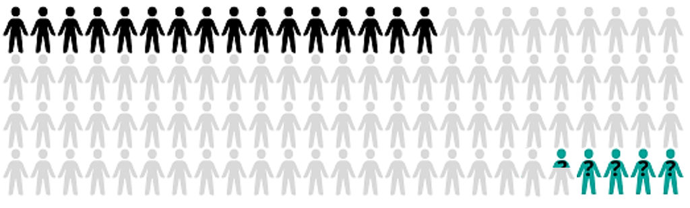


As per the data collected on 31st March 2025; our workforce consisted of 6,627 colleagues. 18.86% were ethnic minority, 77.08% were white, and 4.06% of staff preferred not to say. The proportion of Black, Asian and Minority Ethnic (BAME) staff has increased by 2.97% this year. Yet, there are still some pockets where the representations of ethnic minority staff are small in some groupings and staff grades.
To provide local context to the data, the Lancaster area is approximately 6.9% ethnic minority, Kendal 3.9%, and Barrow 3%, or an average of 4.6% across the Bay, as per the most recent UK Population Census in 2021

iii. Representation, Recruitment and Progression
Representation per AfC bands 1-9 and VSM

Non-Clinical | % BME  23/24 | % BME  24/25 | % White  24/25 | Count BME/  Total |  | Clinical | % BME  23/24 | % BME  24/25 | % White  24/25 | Count BME/  Total
Band 1 | 0% | 0% | 0% | 0 |  | Band 1 | 0% | 0% | 0% | 0
Band 2 | 4.7% | 2.5% | 93.4% | 5/197 |  | Band 2 | 8.2% | 6.1% | 93.0% | 7/115
Band 3 | 1.7% | 1.6% | 97.4% | 6/385 |  | Band 3 | 6.7% | 10.4% | 86.9% | 105/1009
Band 4 | 2.9% | 2.1% | 95.3% | 5/236 |  | Band 4 | 4.3% | 4.3% | 90.6% | 11/255
Band 5 | 2.4% | 1.5% | 95.5% | 1/67 |  | Band 5 | 35.7% | 36.9% | 59.6% | 568/1540
Band 6 | 4.5% | 6.7% | 88.3% | 4/60 |  | Band 6 | 9.8% | 11.2% | 84.3% | 122/1086
Band 7 | 6.1% | 2.4% | 87.8% | 1/41 |  | Band 7 | 4.2% | 4.0% | 91.8% | 25/622
Band 8a | 0% | 0.0% | 94.9% | 0/39 |  | Band 8a | 6.4% | 7.2% | 89.7% | 16/223
Band 8b | 0% | 0.00% | 100% | 0/24 |  | Band 8b | 4.4% | 4.4% | 95.7% | 1/23
Band 8c | 4.6% | 14.3% | 71.4% | 1/7 |  | Band 8c | 0% | 12.5% | 81.3% | 2/16
Band 8d | 10.0% | 0.0% | 100% | 0/6 |  | Band 8d | 0% | 0.0% | 100% | 0/5
Band 9 | 0% | 0.0% | 100% | 0 |  | Band 9 | 33.3% | 33.3% | 66.7% | 1/3
Medical | NA | NA | NA | NA |  | Medical | 55.1% | 56.8% | 34.1% | 365/643
VSM | 0% | 0.0% | 100% | 0/10 |  | VSM | 100% | 100% | 0% | 1/1
Total | 3.4% | 2.4% | 94.75% | 23/  1075 |  | Total | 20.7% | 22.1% | 73.6% | 1224/  5541
Key:
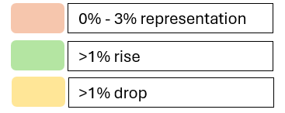
Representation of Ethnic Minority colleagues in each of the AfC bands 1-9 and VSM (including executive board members) compared with white staff.

iii. Representation, Recruitment and Progression
The table in the previous page shows that for the non-clinical roles, in general, the representation of BAME colleagues is minor, as it doesn’t exceed the 2.5%. This figure decreased compared to the last year’s figure of 3.4%. Also, apart from band 8c; there is zero representations for the ethnic minority colleagues in senior roles starting from band 8a onwards.
For the clinical roles the ethnic minority colleagues are fairly represented in most of the AFC bands. There was an improvement in representations and career progression for bands 5 and band 6 roles, compared to the last year. Yet, we’ve a poor representation of 4% in clinical senior roles; in bands 7 and band 8b and null representation at band 8d. Still, we’ve a bottleneck for band 5 roles; having 35.72% BME staff.
Representation of Ethnic Minority colleagues in each Non-Clinical AfC band
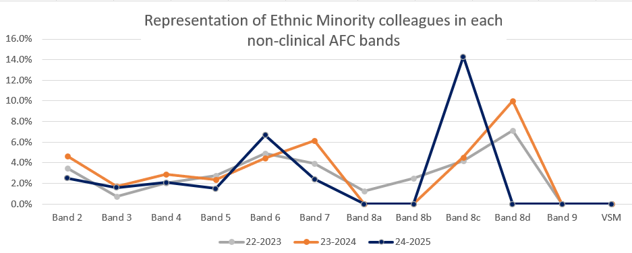
Representation of Ethnic Minority colleagues in each Clinical AfC band
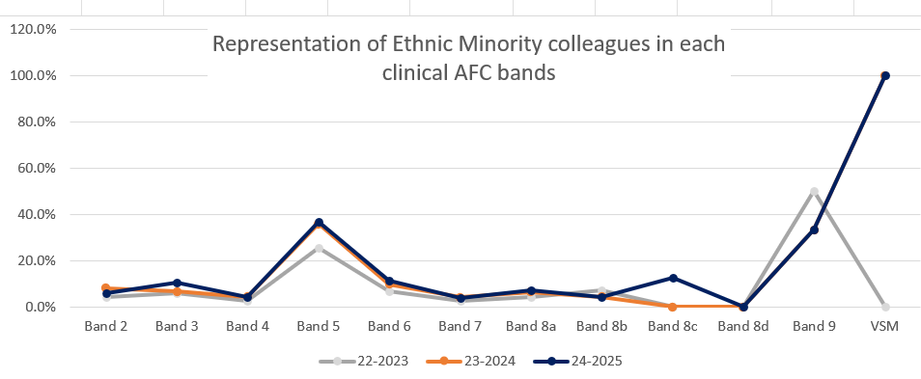
iii. Representation, Recruitment and Progression
Indicator 9 – Voting Board Members
23.1% of the Board's voting membership has an ethnic minority background, compared with an overall BAME workforce representation of 18.9%

This is a major improvement compared to the last year’s figure of 9.1% and compared to the 2023 figure of 7.3%. Great sustained improvement has been achieved in this area.

Indicator 2 – Likelihood of appointment from Shortlisting
White staff are 2.7x more likely to be appointed after being shortlisted. This is a further descent from 2022, 2023 and 2024 when white candidates were 0.83x in 2022 to become 1.44x in 2023 and 2x in 2024

The relative likelihood of appointment from shortlisting means how likely BAME shortlisted candidates will be appointed for jobs after being interviewed compared to their white peers. Therefore, parity is 1. If the relative likelihood is less than 1, it means that BAME are more likely to be appointed for the role than white applicants. If the relative likelihood is more than 1 it means that there is a disparity in the favour of white colleagues.

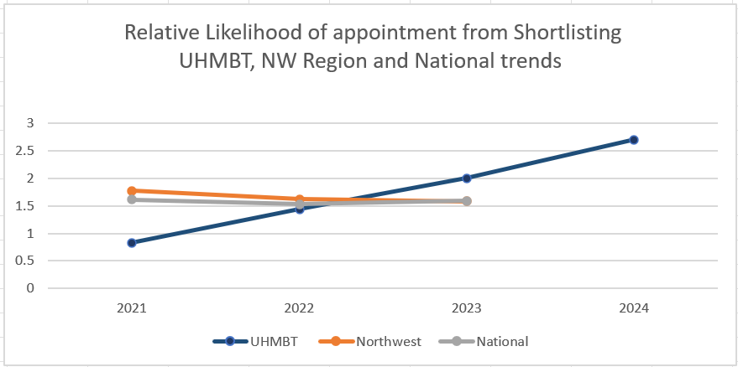
Relative Likelihood of appointment from Shortlisting UHMBT, NW Region and National trends

- Representation, Recruitment and Progression
For 2024/25 figure the relative likelihood is 2.7, which means that white interviewees are 2.7 times more likely to be appointed for the role compared to their BAME peers. This is a further deterioration from 2021, 2022 and 2023 when white candidates were 0.83x in 2021 to become 1.44x in 2023 and 2x in 2024 which surpasses the Northwest regional figure of 1.58 and the NHS national figure of 1.59.

Indicator 4 – Access to non-mandatory training and CPD
White staff are 1.84x more likely to access non-mandatory training and CPD compared to BME staff.

The disparity increased compared to 0.73x figure in 2022 and to 1.58x in 2023. Also, compared to the Northwest figure of 1.14 and the NHS National figure of 1.12.
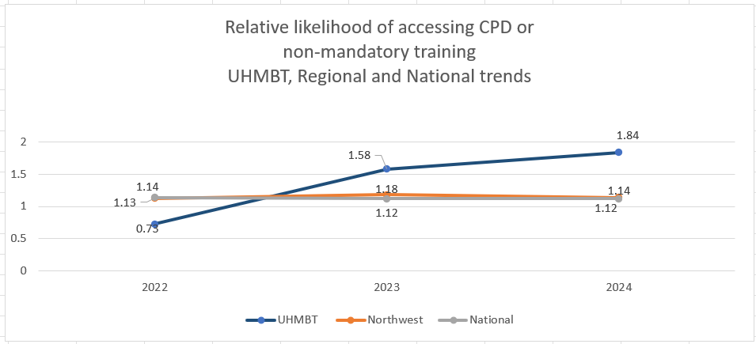
After a great improvement in 2023 with a figure of 0.73% to be in a better-than-equal position, with ethnic minority colleagues 27% more likely to access training than their white counterparts. This year’s figure has declined again to show inequity and changes in the data captured showed that white colleagues are more than three times more likely to access non-mandatory data and CPD. In general, this portion is higher than the Northwest figure of 1.14 and the NHS national figure of 1.12 for the same indicator.

- Representation, Recruitment and Progression
Indicator 7 - Fairness in career progression
53.9% of ethnic minority staff and 55.7% of white staff believe the Trust provides equal opportunity for career progression

The amount of ethnic minority staff who believe the trust provide equal opportunity for career progression increased further this year by 1.3% compared to last year’s BME figure of 52.9% and compared to 2022/23 figure of 48.6%. This figure is also considerably above the national figure of 46.4%.
This is considered as a satisfactory improvement in the favour of BAME colleagues, especially when compared with the white colleagues’ figure, for the same indicator, that decreased this year to be 55.7% compared to 58% the last year and compared to the Trust-wide comparator figure of that also decreased this year by 2% [from 57.2% to 55.2%]. Therefore, a continuous sustained improvement was made in this area.
When breaking down this indicator to compare the figures per various ethnic groups; we find that colleagues from Mixed/Multiple and Other Ethnic groups are the least to believe that the trust provides equal opportunities for career progression. 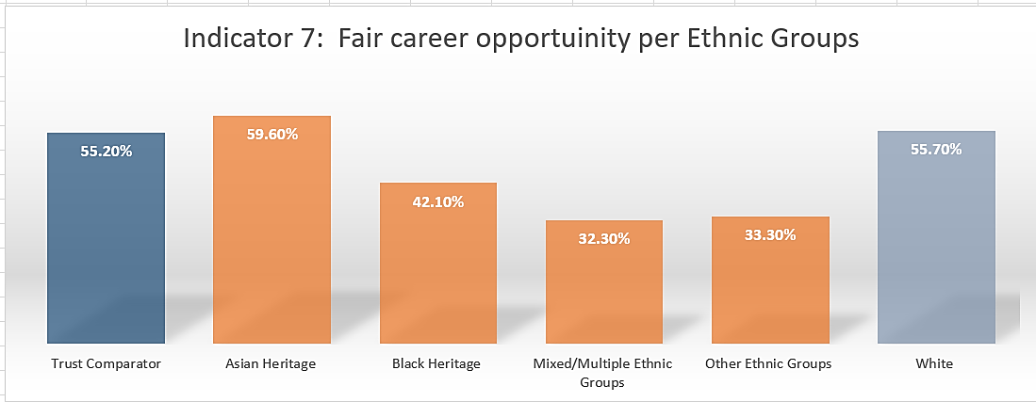
There is a wide disparity of 23% difference in this area in relation to the experiences of the mixed/multiple and other ethnic groups experiences at UHMBT.
Colleagues believe the Trust provides equal career opportunities per Ethnicity.
iii. Representation, Recruitment and Progression
The Asian heritage colleagues’ experiences improved a lot and exceeded the Trust’s comparator figure this year.
Race Disparity Ratio [RDR]
Race Disparity Ratio [RDR] shows the relative likelihood that ethnic minority colleagues to progress through the organisation compared with white colleagues.

The Trust overall workforce disparity ratio from lower to upper is 1.22 which means that, on average, white colleagues are 1.22 times more likely to progress in their careers through the organisation compared to their BAME peers. This portion is quite close to parity and shows that in general the organisation is adopting a fair and equitable approach for career progression.
Race Disparity Ratio [RDR] | UHMBT  2025 | Clinical Roles 2025 | Clinical Roles 2024 | Non-Clinical Roles  2025 | Non-Clinical Roles  2024
lower to middle | 5.63 | 3.28 | 3.32 | 0.36 | 0.58
Disparity ratio - middle to upper | 0.22 | 1.14 | 1.25 | 4.78 | 4.21
Disparity ratio –  lower to upper | 1.22 | 3.73 | 4.14 | 1.70 | 2.46

Yet, this equity in career progression might vary between different bands across the Trust. For instance, the disparity ratio for lower to middle bands across the trust is very high, as the data shows that the white staff are 5.6 times more likely to be promoted from lower bands to Bands 6 and 7.
For the clinical [non-medical] roles despite the improvement from the last year, there is still a wider disparity between BAME and white colleagues for career progression as white colleagues are 3.7 times more likely to get promoted in general. However, the data shows that white colleagues are 3,3 more likely to progress in their careers from lower bands to bands 6 and 7.
While, for the non-clinical roles again there was a great improvement compared to the last year RDR figure of 2.5. Yet, the data highlighted that for the non-clinical roles there is a big and increasing disparity between white and BAME colleagues when it comes to career progression from bands 7 to upper bands [8a and above].
- Formal Disciplinary process
Indicator 3- Likelihood of entering formal disciplinary processes
Ethnic minority staff are 2 times likely to enter the formal disciplinary process than white staff

The 2024/25 figure shows that ethnic minority colleagues are 2 more likely to enter formal disciplinary processes compared to their white colleagues. It shows a deterioration from last year’s figure of 0. 63x yet still above to 2022/23 figure of 2.4x. Also, the figure shows that there is a need to work collectively to make further progress in this area.
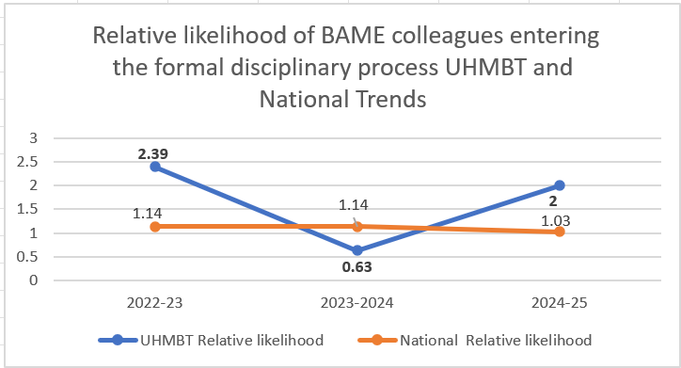
We have now had our Employee Relations Triage panel (which includes Inclusion team representation) in place for over two years, and last year saw an improvement in a reduced number of BAME colleagues entering formal disciplinary processes. The panel remains in place and reviews all cases referred for formal disciplinary process. Cases only progress after all aspects, including EDI factors, have been considered and it has been confirmed by the panel that progression to formal stage is appropriate. This process needs to be preserved to keep the good practice to ensure fairness in processes are maintained, and to avoid any further increase in this figure the next year.
Further discussions with the employment services colleagues would be helpful to explore and improve the proportion of BAME colleagues entering other HR formal process such as probationary formal review and performance review.
- Behaviour and Discrimination
Indicator 5-bullying and harassment from the public

27.9% of ethnic minority staff and 22.2% of white staff have experienced bullying, harassment or abuse from patients in the last 12 months.

There was a slight increase of 1% in the number of BAME colleagues who experience bullying, harassment or abuse from patients, relatives, or the public in the last 12 months, compared to the last year’s figure of 26.9% for the ethnic minority staff and 21.4% for white staff have experienced bullying,
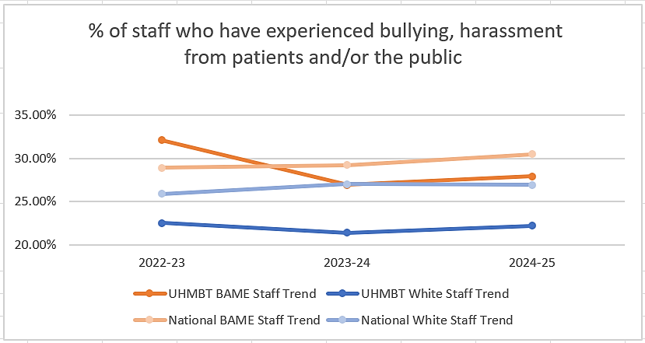

Despite this increase UHMBT figure of 27.9% still below the national figure of 30.5% for the same indicator. The white colleagues’ figure this year has improved slightly which left a gap of 5.7% between the 2 groups’ experiences. This is consistent with the national trends, however, the 5.7% gap between BAME and White colleagues’ experiences at UHMBT is still wider than the 3.6% nation-wide gap between the 2 groups.
Yet, the experiences of ethnic minority colleagues are not always the same. Scrutinising further the WRES data per ethnic groups; it was obvious that some ethnic minority groups like the “Asian/ Asian British” are the most ethnic category that experienced higher bullying from patients/public during the former year.

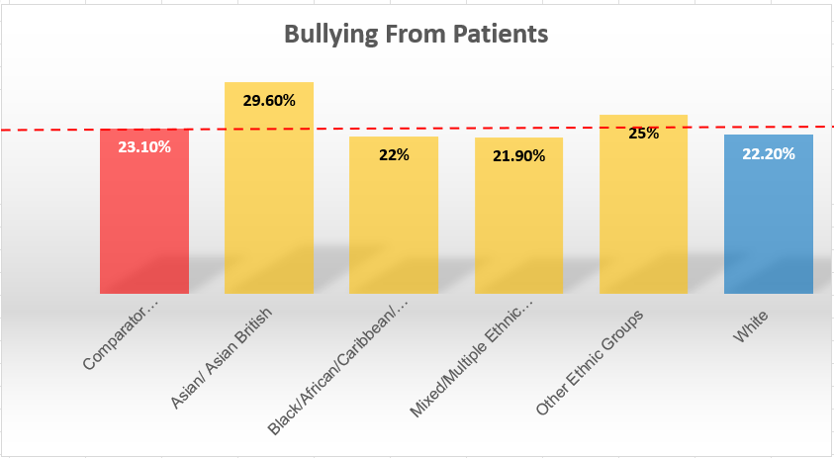
- Behaviour and Discrimination
% of staff who have experienced bullying, harassment or abuse from patients/public in the last 12 months, split by ethnic background.

Indicator 6- bullying and harassment from staff
24.3% of ethnic minority staff and 23.4% of white staff have experienced bullying, harassment or abuse from staff in the last 12 months.

This figure considerably decreased compared to the 2023/24 figure of 26.8% and compared to the 2023 figure of 32.1%. While the white colleagues’ figure for the same indicator almost remains the same this year, with a very slight decrease from 23.9% to 23.4%.
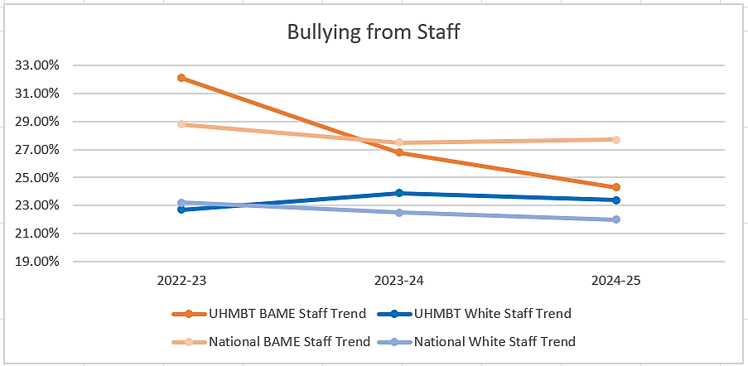
- Behaviour and Discrimination
Significant consistent improvement for ethnic minority colleagues for this indicator as a group attained since the 40% in 2021 figure. The indicator has ticked up slightly in 2022/23 but has broadly maintained its consistent improvement.
The UHMBT figure this year decreased greatly compared to the national figure of 27.7%. It worth noting, also, that the national figure for this indicator slightly increased this year from 27.5%.
Also, the disparity between the experiences of the BAME and White colleagues considerably diminished this year to be 0.9% compared to the last 2 years’ wide disparity, leaving the two groups in a very close position towards the parity of experiences. A very good sustained continuous improvement has been made in this area.
However, underneath this improving measure, the impact on certain ethnic minority groups is unequal and requires further scrutiny.
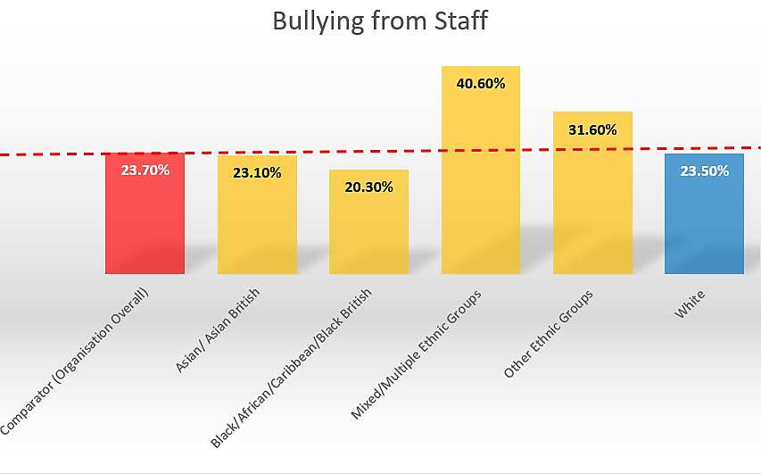
% of staff who have experienced bullying, harassment or abuse from Staff in the last 12 months, split by ethnic background.

As shown in the graph above: the “mixed/multiple ethnic groups” and the “other ethnic
groups” are the most to experience bullying from colleagues at workplace.
- Behaviour and Discrimination
Also, the experience of the “other ethnic groups” staff despite its increase this year continues to be significantly poorer than all other ethnic groups, as shown per the graph below.
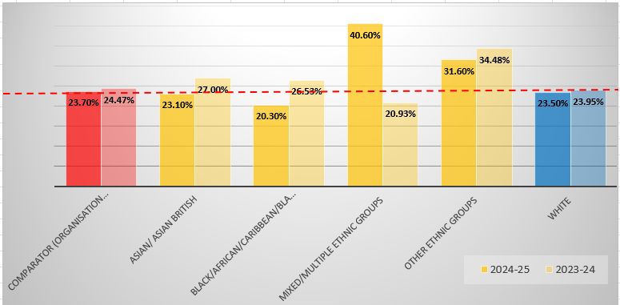
Bullying From Staff per Ethnic Groups 2023/24 vs 2024/25

The mixed/multiple ethnic groups experienced a spike to their figure to be 40.6% compared to being below the trust comparator during the last year. Yet, the graph above shows that over the course of the last two years there was almost a steady of improvement in the experiences of all ethnic minority groups colleagues, apart from the mixed/multiple ethnic groups.

Indicator 8 - experience of discrimination
16.8% of ethnic minority staff and 6.8% of white staff have experienced discrimination from staff in the last 12 months

This year there was a considerable sustained great improvement compared to the 18.3% figure in 2023/24 and from the 2022/23 figure of 22.4%.
Also, this year the UHMBT figures for both BAME and white colleagues were very close to the national figure for the same indicator of 16.60% for BAME and 6.7% for white NHS staff nation-wide.

- Behaviour and Discrimination
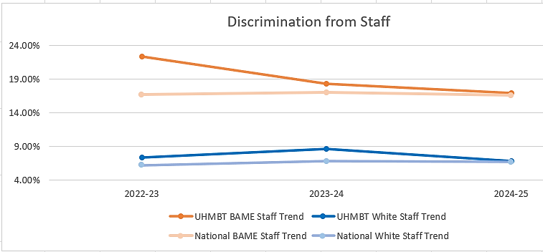
Yet, despite this continuous improvement the disparity between the experiences of white and BAME colleagues are still wide and shows inequality as BAME staff are 2.5 times more likely to experience discrimination at work compared to their white peers.
When scrutinising further this indicator per ethnic groups, we found that there was a general decrease in the experiences of discrimination across the various ethnic groups, apart from the Asian heritage ethnic groups figure that slightly increased from the last year. It worth noting that this indicator figure for the “Black heritage groups” and for the “other ethnic groups” has greatly decreased compared to the last year. While the Trust’s comparator and the white colleagues’ figures both were almost constant compared to the last year.
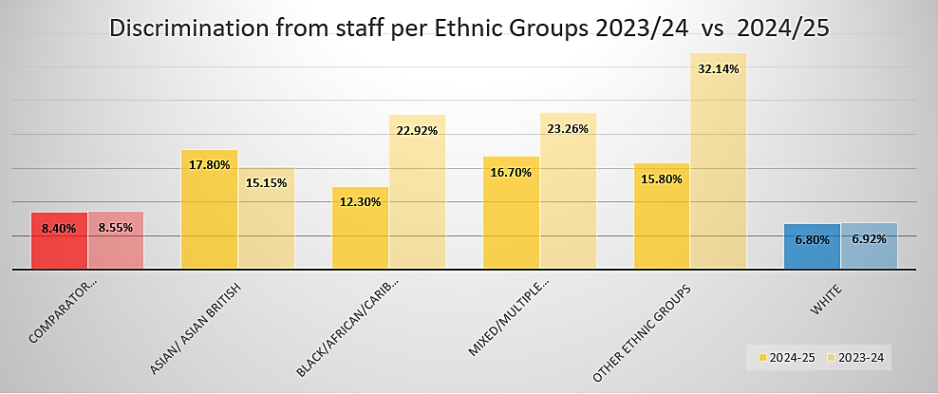
- Narrative
Introduction:
“As a Trust, UHMB is commitment to eliminating racism, to stand with our colleagues when they experience it, and to eradicate the inequalities in access, outcomes and experiences of healthcare that some of our communities’ face.” By Paul Jones, UHMB Trust Secretary and the Trust race equality executive sponsor.
Through the last year the Trust took practical steps to improve the experience of our ethnic minority groups, on various levels with a focus on discrimination and workplace experience. We achieved milestones throughout the last year in this area; we designed the zero-hate policy and zero-hate communication campaign, we ran Anti-Racism Influencers Group sessions, we developed the inclusive recruitment ambassadors programme and published the Trust’s public-faced anti-racism statement, we supported plenty of BAME on case-management level, the previous is just a prime example of our input during the former year. Importantly, our BAME staff network and chairs are playing a key role along with allies and senior leaders using their position and power to make changes and influence others.
During the civil unrest in August 2024, we made uncompromised statements against racism and islamophobia. We ensured that we are approachable for all BAME colleagues by championing and attending emergency support meetings that were followed by further supportive actions. Feedback from BAME colleagues was that this visibility made a big difference to how they felt backed by their organisation.
On a positive note: In March 2025, UHMBT was awarded the Northwest Anti-Racism Bronze Award for the first time. UHMBT was the first Trust across the Northwest ICS trusts to achieve this accreditation from the first submission. The Award highlights the Trust's commitment to being an intentionally anti-racist and fully inclusive organisation. Significant evidence of anti-racist activities across various domains and teams were required for the award application, including the publication of an anti-racist statement, the appointment of an executive Equality, Diversity and Inclusion (EDI) sponsor with a commitment to advancing anti-racism within the organisation, tackling racism as a mission critical across the Trust, and proof of planning for continuous anti-racism work.
We acknowledge there are still existing barriers for BAME colleagues at UHMBT and in our communities, and that further work is needed to dismantle systemic and structural racism to improve BAME colleagues experiences. Our Board’s members scrutinise themes emerging from WRES data, and the work done across the Trust to mitigate the gaps.
There are also some aspects that are out the Trust’s control that could negatively influence our ethnic minority staff experience for instance the new UK immigration and Visa Sponsorship rules that led to the unfortunate loss of BAME staff whose bands do not meet the new visa salary thresholds.
- Anti-Racism Strategy and Action Plan

Anti-Racism Strategic work at UHMBT
Our anti-racism strategic work at UHMBT is mainly focused on four key areas:
- Improving representation per AFC and BAME staff career progression [to ensure fairness in career progression and representation]
- Fairness in Processes [to ensure fairness in formal processes]
- Zero-Hate Approach [to tackle unlawful behaviour & Discrimination]
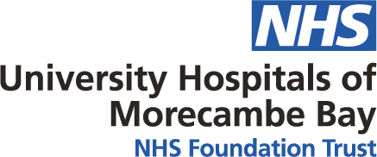
- Stakeholders’ Engagement and Accountability

NHS Workforce Race Equality Standard (WRES)

Action Plan 2025-2026
Outcomes | Actions | Leads | Timescale
I. Representation per AFC, Career progression/ Promotion, Recruitment
Indicator 1 & Indicator 2 & Indicator 4
Trust and fairness of recruitment processes. | - Implementing Values Based Recruitment (VBR) Training | Learning and Development Team | March 2026
Well-informed and accountable Inclusive Recruitment Ambassadors [InRAs] | - Design and Running the InRAs training/workshops monthly | Inclusion Advisor | March 2026
Consistency to ensure equal engagement opportunities for all recruitment ambassadors to contribute to various recruitment panels | - Designing the ambassadors’ appointment process | Inclusion Advisor  +  Project Support Administrator | March 2026
An expanded Inclusive Recruitment Ambassadors (InRAs) Programme by providing extra resources/guidance related to fair inclusive recruitment. | - The design of resources SharePoint page for recruitment ambassadors and recruiting managers | Inclusion Advisor | March 2026
Divisional focus and raising awareness on enhancing career progression for BAME staff and fair recruitment  And  Divisional Inclusion action plan to Recruit recruitment ambassador’s cohort per division to assist fair recruitment practice | - Implement data dashboard to report on key BAME workforce metrics related to Recruitment and career progression. | Inclusion Advisor  +  HRBPs | Dec 2025
Raising awareness across the Trust on the inclusive recruitment work promote and enhancing participation in existing recruitment VBR and InRA Trainings | - Inclusive Recruitment Communication campaign | Inclusion Advisor  +  Project Support Administrator  +  Comms Team | March 2026
Increasing InRAs’ numbers in each division | - Divisional promotions for inclusive recruitment practice as part for the division people plan | HRBPs  +  Inclusion Advisor | March 2026
Support internal candidates who are applying for alternative roles within the Trust, application forms, and interview/presentation skills | - Promote for career progression TMS personal development training packages through BAME Staff Network | Inclusion Advisor +  BAME Staff Network | March 2026
Devise and induce inclusive recruitment to managers | - Create a PMDP resources hub re inclusive recruitment | Inclusion Advisor | March 2026
Inclusive recruitment on the top of inclusion action plan related to each division | - Divisional action related to inclusive recruitment | Inclusion Advisor  +  HRBPs | March 2026
Enhance outcomes related inclusive recruitment and BAME staff access to CPD. | - Refresh Trust’s appraisal training to include WRES career progression and recruitment data | Inclusion Advisor  +  LD Team | March 2026
Support for BAME internal applicants in career progression | - Consider the adoption of different inclusive recruitment processes such as the multi-assessment centres | Head of Colleagues Experience | Dec 2026
More accuracy in indicator 4 the data extracted from TMS to improve | - Accurate recording of all TMS training to ESR for consistency purposes | I3 Team | March 2026
II. Fairness in processes
Disciplinary Processes - Indicator 3
Sharing lessons learned from HR cases and ensure continuous improvement of our people’s practices processes, especially for BAME staffing | - The Trust will continue to deliver a case Triage process for employee relations (ER) cases | CPO  +  Head of Operational People Services | Dec 2025
Equipping Middle and Senior managers with the skills required to undertake ER cases | - Divisional level training on Anti-Racism and Allyship to include topics such as unconscious bias and Just Culture. | Inclusion Advisor  +  HRBPs | March 2026
Ensure Fairness in processes for BAME staff | - Inclusion of a BAME third party [The Trust will benefit from our REAG and InRA colleagues to attend HR process as a 3rd independent representative body] in all HR formal processes | HRBPs  +  Inclusion Advisor | Dec 2025
III. Zero-Hate Approach
Behaviour and Discrimination: Ind 5 -Ind 6 -Ind 8
Eliminate unlawful behaviours such as bullying, harassment discrimination, and racism | - Design and implementation of the Zero-Hate policy | Inclusion Advisor | March 2026
Promoting and raising awareness of policies and the range of support available for staff in case of hate incident | - Developing Zero-Hate communication campaign. | Inclusion Advisor  +  Comms Team | March 2026
Create a psychologically safe sessions that includes [ a bite-size learning - staff experiences and stories – discussion on small action sets]. Psychologically safe sessions that includes [ a bite-size learning - staff experiences and stories – discussion on small action sets], the group is mainly based on the allyship idea. | - ARIG - Anti-Racism Influencers Group reviewed and re-instated | Executive Sponsor for Race Equality  +  Inclusion Advisor | March 2026
Increase the active engagement of our stakeholders and colleagues who are interested in actively contributing to the WRES action plan implementation. | - Develop REAG – Race Equality Action Group | Executive Sponsor for Race Equality  +  Inclusion Advisor | March 2026
Bridge gaps related to discrimination and bullying pockets across the Trust and make a target intervention. | - Bespoke anti-racism divisional sessions | Head of Colleagues’ Experience  +  Executive Sponsor for race equality  +  Inclusion Advisor | March 2026
Encouraging the promotion of reporting incidents of violence or aggression from patients/the public via Ulysses. | - Raising awareness on reviewing Ulysses data relating to violent incidents across the organisation. | Inclusion Team  +  BAME Co-Chairs | March 2026
Sharing and giving the ownership of data to the divisional triumvirate and the HRBPs | - Implement WRES Dashboard to report on key workforce metrics relating to each division and WRES key hot spot areas across the Trust. | Inclusion Advisor | March 2026
Triangulating the WRES outcomes and identifying key areas that require target interventions [Surgery RLI Theatre case-study] through qualitative data collections | - Enhance current data collection, qualitative data collection, analysis and reporting processes for racial discrimination. [joint data collection and analysis work between the Freedom to Seak UP Guardian Team [FTSU], Inclusion Team and Matrons/Ward Managers]. | FTSU  +  Ward Leadership  +  Inclusion Advisor | Sep 2026
Cultivate a sense of inclusivity and belonging across the organisation | - Develop an inclusion calendar of events to highlight various religious celebrations and race related key inclusion events | Communication Team  +  Inclusion Team | March 2026
Raising awareness on what is inclusion and cultural awareness  Bringing bias to the forefront.  Belonging in the workplace.  Celebrating differences. | - Develop a schedule of events for the BHM [Black History Month] as a prime key BAME event to raise awareness as sample of events to include | Inclusion Advisor  +  BAME Co-Chairs | Oct 2025
Raising awareness on what is inclusion and racism, horn biases and discrimination in the workplace. | - Develop Anti-racism training package | Inclusion Advisor | Sep 2025
Create a wider cohort of Allys to support the inclusion culture | - Develop Allyship training package | Inclusion Advisor | Sep 2025
Resolve any occurring issue before escalation to formal process | - Restorative Practice Service to resolve workplace issues between staff, colleagues and managers. | OD Team | March 2026
IV. Stakeholders’ Engagement and Accountability

Leading by example - Visibility of the VSM Sponsorships & Leadership | - The Nomination of an Executive Director for the advancement of the race equality agenda at UHMBT. | Executive Members  +  Inclusion Advisor | March 2026
Leading by example - Visibility of the VSM Sponsorships & Leadership | - Board of Executives sponsorships and objectives in relation to the anti-racism work, such as BAME Staff Network Executive sponsor and race equality patients experience work Executive sponsor. | Executive Members  +  Inclusion Advisor | March 2026
Leading by example Divisional Triumvirates Accountability | - Engaging the divisional triumvirates to agree on divisional WRES and inclusion action plan | HRBPs  +  Inclusion Advisor | Sep 2026
Strengthen the representation of our BAME community voice | - Continuing to empower and support the BAME Staff Net | BAME Co-chairs  +  Inclusion Advisor | March 2026

