Workforce Sexual Orientation Equality Standard Report

2024-2025

Background
Our Workforce Sexual Orientation Monitoring Standard (WSOES) uses similar indicators to the national Workforce Race Equality and Disability Equality Standards with specific indicators agreed with our LGBT+ colleague network. We have begun to explore how to further develop this standard to enable us to monitor colleague experience based on trans status and gender identity.
Currently, the employee record system (ESR) does not allow for trans status or identities outside of the binary (i.e. man/woman) to be recorded. As many of the indicators rely on this data, this is preventing us from doing so. We are actively lobbying for this to be updated nationally by the Department for Health and Social Care. It is important to us that we are taking steps to understand the experience of our trans and non-binary colleagues in our workplace.

Summary of Data
The latest WSOES data reveals a mixed picture of progress and ongoing challenges in LGB+ inclusion. There are some encouraging signs: LGB+ candidates are being appointed at a fair rate compared to heterosexual candidates, with the relative likelihood increasing to an equal 1.00. Importantly, no LGB+ colleagues entered the formal disciplinary process in either year, suggesting equity. Additionally, access to non-mandatory training and CPD for LGB+ staff has improved significantly, rising from 0.81 to 1.23, indicating growing opportunities for this community.
However, areas for improvement remain. There is still no visible LGB+ representation in Board voting membership, which is critical to inclusive leadership. Also, LGB+ colleagues continue to report higher levels of bullying, harassment, and abuse. In 2024/25, 19.9% of gay or lesbian and 22.0% of bisexual staff reported abuse from managers, compared to just 9.2% of heterosexual colleagues. Experiences of bullying from other colleagues also remain disproportionately high, particularly for bisexual staff, rising to 36.6% compared to 17.4% among heterosexual peers.
In summary, while positive strides have been made in recruitment fairness, training access, and disciplinary procedures, the data highlights persistent inequalities in representation and lived experience for LGB+ colleagues. These findings point to the need for a focus on inclusive leadership, targeted support for bisexual staff, and interventions to reduce harassment and foster a more positive working environment for our LGB+ colleagues.

Table of 2024 – 2025 WSOES Results

 | 2023/24 |  |  | 2024/25
Indicator 1: % of LGB+ colleagues in each of the Agenda for Change bands 1-9, medical and VSM compared with colleagues in the overall workforce | 2.51 |  |  | 2.45
Indicator 2: Relative likelihood of LGB+ Candidates being appointed from shortlist compared to that of heterosexual candidates across all posts. | 0.92 |  |  | 1.00
Indicator 3: Relative likelihood of LGB+ colleagues entering the formal disciplinary process, compared to heterosexual colleagues, as measured by entry into formal disciplinary investigation (across a 2-year reporting period). | N/A (no LGB+ colleagues entered the formal disciplinary process) |  |  | N/A (no LGB+ colleagues entered the formal disciplinary process)
Indicator 4: Relative Likelihood of LGB+ Colleagues accessing non-mandatory training and CPD compared to heterosexual colleagues | 0.81 |  |  | 1.23
Indicator 6: % of LGB+ colleagues who experienced, bullying, harassment or abuse at work from their managers compared with heterosexual colleagues. | Heterosexual | Gay or Lesbian | Bisexual | Heterosexual | Gay or Lesbian | Bisexual
 | 9.1 | 17.0 | 10.0 | 9.2 | 19.9 | 22.0
Indicator 7: % of LGB+ Colleagues who experienced bullying, harassment and abuse at work from other colleagues compared with heterosexual colleagues | 19.4 | 34.0 | 34.5 | 17.4 | 40.5 | 36.6
Indicator 8: % difference of LGB+ colleagues in our Board voting membership compared to overall workforce | No visible LGB+ representation on the Board voting membership |  |  | No visible LGB+ representation on the Board voting membership

Improvements and Sustained Positive Outcome
Indicator 3: Relative likelihood of LGB+ colleagues entering the formal disciplinary process, compared to heterosexual colleagues, as measured by entry into formal disciplinary investigation.
No LGB+ colleagues entered the formal disciplinary process.

Deterioration
Indicator 1: % of LGB+ colleagues in each of the Agenda for Change bands 1-9, medical and VSM compared with colleagues in the overall workforce
The percentage of LGB+ colleagues followed an upward trend until 2022/23, where it plateaued. This year, the percentage has fallen very slightly from the previous year.

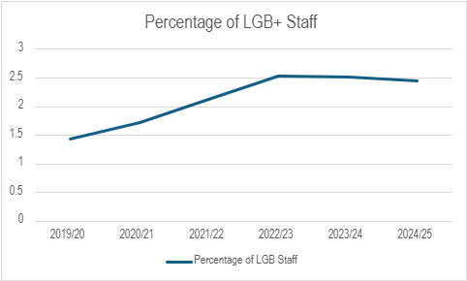

The 2024/25 breakdown of demographics can be seen on the chart below:

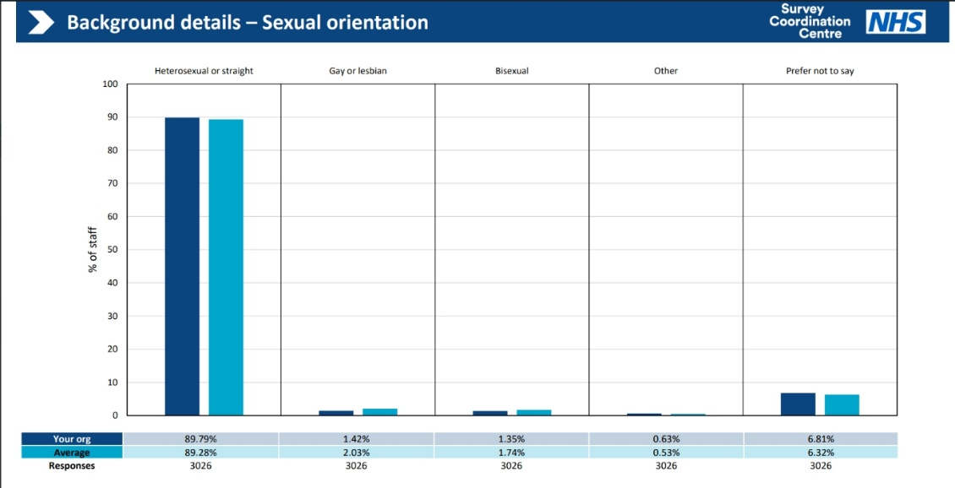

Indicator 6: % of LGB+ colleagues who experienced, bullying, harassment or abuse at work from their managers compared with heterosexual colleagues.
This metric has seen a rise, most notably for bisexual staff, whose experience of bullying, harassment or abuse at work from their managers has over doubled since last year.
Indicator 7: % of LGB+ Colleagues who experienced bullying, harassment and abuse at work from other colleagues compared with heterosexual colleagues.
Heterosexual staff have experienced less bullying, harassment and abuse at work from other colleagues than the previous year. However there has been an increase in these cases for gay/lesbian and bisexual staff.
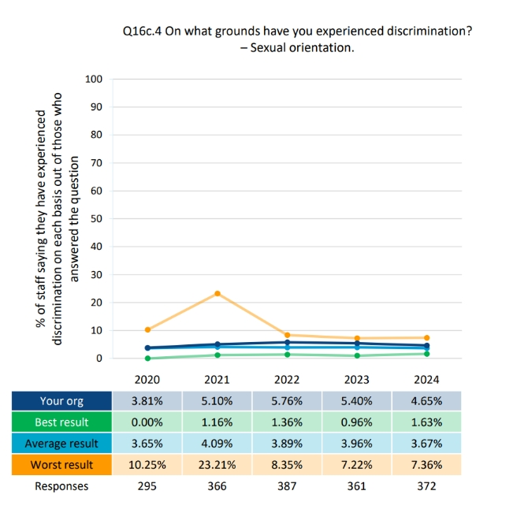
Trans Colleague Experience
It is important to us that we are taking steps to understand the experience of our trans and non-binary colleagues in our workplace. We have access to some data from the NHS Staff Survey from colleagues who are non-binary or choose to self-describe their gender identity. However, unfortunately, the number of colleagues who told us that their gender identity was different from the one they were registered at birth was too small to report in 2023/24 (9 colleagues who answered the staff survey self-identified in this group and the suppression threshold is 10). This year, the number was smaller at 6 colleagues.

Conclusion
The latest data highlight several key areas to prioritise to improve the experience of LGB+ colleagues at the Trust. Firstly, representation remains low at only 2.45%. There remains no visible LGB+ representation on the voting Board. This indicates a need to focus on increasing representation at senior levels. Also, voluntary self-disclosure should continue to be encouraged.
Recruitment practices appear equitable in terms of relative likelihood of appointment. Access to non-mandatory training and CPD has also improved. These positive trends should be sustained. No LGB+ colleagues entered the formal disciplinary process in the last two years.
However, bullying, harassment and abuse remain significant and have worsened this year. LGB+ colleagues, particularly those identifying as bisexual or gay/lesbian report disproportionately high levels of bullying from managers and colleagues. These figures demand urgent action, including reinforcing recently published zero-hate policy. Overall, the Trust should focus on improving LGB+ visibility and representation in leadership, address bullying and harassment and encourage colleagues to feel safe in disclosing their identities. See our detailed Action Plan here:

WSOES Action Plan 2025 - 2026

Outcomes | Actions | Leads | Timescale
Our trans and non-binary colleagues feel a greater sense of safety and belonging. | - Continue to run support sessions following the Supreme Court Ruling on Gender. | Respect and Civility Lead/Strategic EDI Lead | Ongoing
Consider becoming a member of Stonewall again to access more in-depth specialist matter expertise and gain equality index status. | - Measure the interest of this with the LGBT+ network and determine whether the budget is available. | Strategic EDI Lead | September 2025
Increased awareness of our LGBTQ+ training offer. Managers equipped with a greater awareness of LGBTQ+ issues. | - Utilise events such as Pride Month and LGBTQ+ History Month to promote our training offer through multiple channels. | Strategic EDI Lead/Respect and Civility Lead | December 2025
Aim to increase NHS Rainbow Badge Scheme, including purchasing new badges | - Explore funding for the purchasing of new badges. | Strategic EDI Lead | December 2025
Higher rates of declaration on ESR, less ‘prefer not to say’. | - Launch an ESR declarations campaign and encourage declarations throughout the year. | Inclusion Team | January 2026
Reduction in discrimination due to sexual orientation. | - Increase civility at work worships. Increase manager and leaders' awareness through PMDP/Leadership induction. Promotion of Zero Hate Policy and Campaign. Monitoring of Zero Hate related incidents and reports to FTSUGs through Triangulation Group. | Strategic EDI Lead/Respect and Civility Lead | March 2026

