Stool Diary:
You will find below a two week stool diary with instuctions on how to correctly fill the chart in. Please complete before your appointment with our Team. Without these we are unable to progress forward with treatment options. If you are given these charts during a clinic appointment you are required to return them within a four week period to the email addresses below. Any charts not returned will result in a referral being discharged from the service.
Once complete please return to the email/postal address provided:
Child.bladderandbowel@mbht.nhs.uk
Integrated Children’s Nursing and Therapy Team
Children’s bladder and Bowel Team
Ryelands House
Owen Road
Lancaster
Lancashire
LA1 2LN – Tel: 01524 518966

Instructions for parents completing a Stool Diary:
- Write down every poo that is passed, even if it is a little stain in the child’s pants.
- In the Type column, write down the number from the Bristol Stool Chart that best describes the poo – see Table 1 below.
- Fill in the diary for a two week period, or longer if your doctor or nurse asks you for it.
- At the end of every day, check to make sure no poos were forgotten. Write in whatever laxatives have been taken that day, including the dosage.
- Record the amounts of stool passed as small/medium/large etc.
- In the Comments column, write down anything you think may be helpful, such as if your child had a tummy pain or was sick.
- Some children use suppositories/enemas or washouts to help them poo. Note in the last column if/when your child uses any of these.
If you have any further questions or require additional support completing the forms, please do not hesitate to contact a member of the Bladder and Bowel Team: 01524 518966
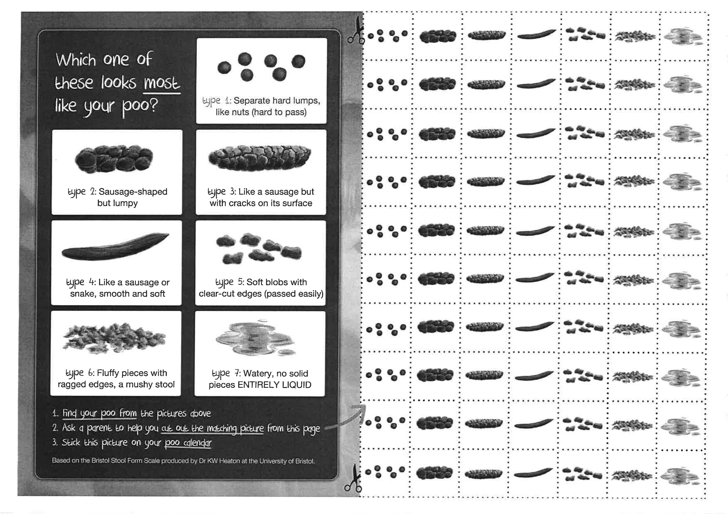
Childs’s Name:
DOB:
Address:
DATE  eg:1.122 | TIME  eg:8am/1pm/6pm | POO IN THE TOILET? TYPE AND AMOUNT  eg: type 7 small/type 6 small | ANY SOILING?  AMOUNT?  eg: no/yes-more than a skid mark | COMMENTS  eg: soiling was porridge consistency/tummy pain etc. | LAXATIVES?  NAME AND DOSAGE  eg:x1 sachet of Laxido at 9am | SUPPOSITORIES/ENEMAS/BOWEL WASHOUTS?  NAME AND DOSE  eg:no

Childs’s Name:
DOB:
Address:
DATE  eg:1.1.22 | TIME  eg:8am/1pm/6pm | POO IN THE TOILET? TYPE AND AMOUNT  eg: type 7 small/type 6 small | ANY SOILING?  AMOUNT?  eg: no/yes-more than a skid mark | COMMENTS  eg: soiling was porridge consistency/tummy pain etc. | LAXATIVES?  NAME AND DOSAGE  eg:x1 sachet of Laxido at 9am | SUPPOSITORIES/ENEMAS/BOWEL WASHOUTS?  NAME AND DOSE  eg:no

