Fluid chart Information:

You will find below copies of a 48 hours Fluid Chart with instructions on how to correctly fill the Chart in. Complete before your appointment with our Team. Without these we are unable to progress further with treatment options. If you are given these Charts during a clinic appointment you are required to return them within a 4 week period to the email/address below. Any charts not returned will result in the referral being discharged from the service.
Child.bladderandbowel@mbht.nhs.uk
Integrated Children’s Nursing Team
Children’s Bladder and Bowel Team
Ryelands House
Owen Road
Lancaster
Lancashire
LA1 2LN

FLUID CHART INSTRUCTIONS

The fluid chart is designed to help your doctor or nurse see how your child’s bladder and bowel are working. Please complete for 48 hours as this will give us a better picture of the problems you are having. For 48 hours we ask you to write down everything your child drinks, wees, poos and any wetting episodes in their pants or bed, as detailed above.
- The TIME column - Sets out the time of day in the 24-hour clock.
- The FLUID AMOUNT column – Measure each drink in mls and write that amount in the column next to the time they drink it.
- The FLUID TYPE column – Write in the type of drink your child is having i.e. water, diluted juice, milk, tea or coffee.
- The URINE (WEE) column – You will need an old jug to measure every wee your child has during the 48 hours.
- The PANTS column – Write down every time your child has wet pants. If your child does not have problems through the day, please ignore this column.
- The BED column – Write down when the bed is wet. If wet more than once per night, write in each time. Also, write in if your child has a dry night.
- The POO column – Write in each time your child has a poo. Have a look on the Bristol Stool chart below and write down what type you think the poo is.

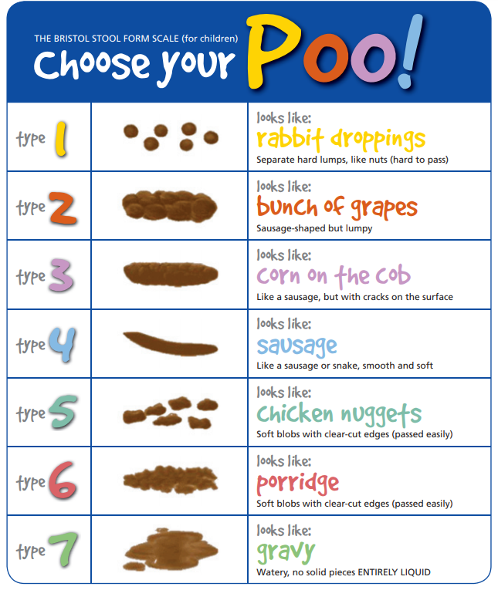

Child’s name: DOB: Address:
TIME | FLUID AMOUNT | FLUID TYPE | URINE (WEE) | PANTS-DRY/DAMP/WET | BED-DRY/DAMP/WET | BOWELS (POO)
01:00
02:00
03:00
04:00
05:00
06:00
07:00
08:00
09:00
10:00
11:00
12:00
13:00
14:00
15:00
16:00
17:00
18:00
19:00
20:00
21:00
22:00
23:00
24:00

Child’s name: DOB: Address:
TIME | FLUID AMOUNT | FLUID TYPE | URINE (WEE) | PANTS-DRY/DAMP/WET | BED-DRY/DAMP/WET | BOWELS (POO)
01:00
02:00
03:00
04:00
05:00
06:00
07:00
08:00
09:00
10:00
11:00
12:00
13:00
14:00
15:00
16:00
17:00
18:00
19:00
20:00
21:00
22:00
23:00
24:00
If you require any further assistance or would like to talk to a member of the Bladder and Bowel Team contact:
Child.bladderand bowel@mbht.nhs.uk
Address: Integrated Children’s Nursing and Therapy Team
Children’s Bladder and Bowel Team
Ryelands House
Owen Road
Lancaster
Lancashire, LA1 2LN, Tel: O1524 518996

