Oracle Fusion User Guide
(End User Version)

Contents

Chapter 5 – Receipting

Chapter 5 – Receipting

System Navigation
From the Home screen; click on My Receipts.

Booking In
If an order is delivered into Receipt & Distribution, the order will be booked in (or receipted) by the R&D team. If however, an order is delivered direct to a department (or relates to a maintenance contract) then it is the responsibility of the end user to book in the order. Please note that an end user is only able to book in orders they have raised.

On the Receive Items screen, make sure that the Requestor box contains your name, set the Items Due box to Any Time and enter the Purchase Order Number into the Purchase Order box (all PO Numbers in Fusion start UHMB e.g. UHMB0000001). Click Search.

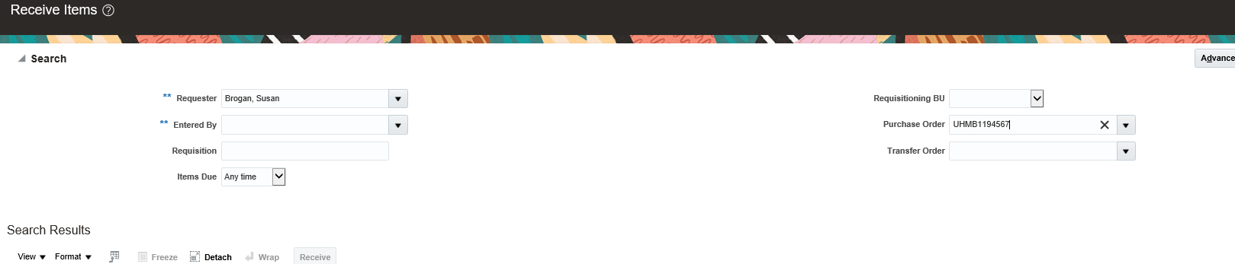

Highlight the line to be booked in by clicking on the line (do not click on the Requisition Number or the Order Number as this will take you to a different screen) – the line will turn blue to confirm it has been selected. If you need to book in multiple lines, hold down Ctrl on your keyboard then click on all the required lines.

Click Receive.

Click Show Receipt Quantity which will display the quantity that was initially ordered in the Quantity column. If the full quantity has not been delivered, edit the quantity as required. Enter the delivery note reference (found on the paperwork from the supplier) into the Packing Slip box then click Submit. The Receipt Number will be confirmed on screen.

If an invoice is attached to the order before the goods are booked in then an electronically generated chase email will be sent.

Corrections
If an amendment is required to the quantity on an existing receipt, click My Receipts, then the Tasks button (looks like a rectangle with three lines inside) on the right-hand side of the screen and select Manage Receipts.
If you know the Receipt Number or the Purchase Order Number then enter either one into the relevant search box and click Search. If you do not have either number then leave all of the search boxes empty and press Search – this will show all of your created receipts.

As with creating the receipt in the first place, highlight the line(s) to be booked in by clicking on the line(s) then click Correct.

Enter the updated quantity in the Correct Quantity box and click Submit.

Returns
If an item needs to be returned for any reason, please contact a member of the Procurement team who will be able to explain the process and produce the required paperwork.

